**Phase 86**

Now we see our preview to see is our data layer getting the data from our website

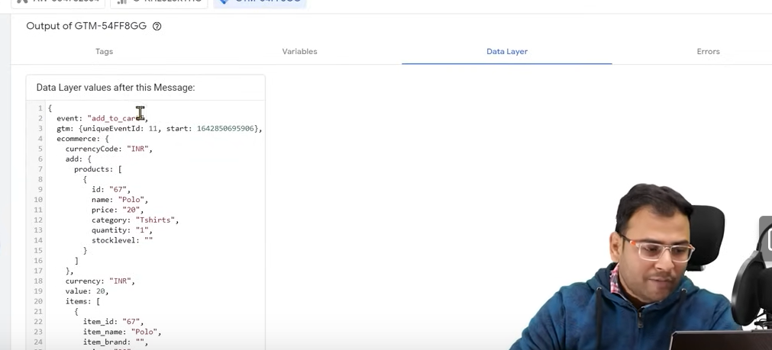

Now in above in data layer you can see the data

In data you can see the event that is happened in your website now in data you can see that event is “add to cart” Currecy data that is INR and product id etc

Preciously we did not have data we were jut saying that if this pageview happen then make this event

Now id there is data in data layer then on the basis of that we can make data layer variables and on the basis of these data layer we can send our data to any place.

Our main purpose it to send it to facebook pixel but from here starts enhanced ecommerce measurement using Google Analytics. We do the same things here we collect data from data layer and send it to google analytics with help of variable or tags and we can see the our data there

Now we have data now we just need to simply send it with facebook other event to facebook

Now if we go to event manager and in our pixel

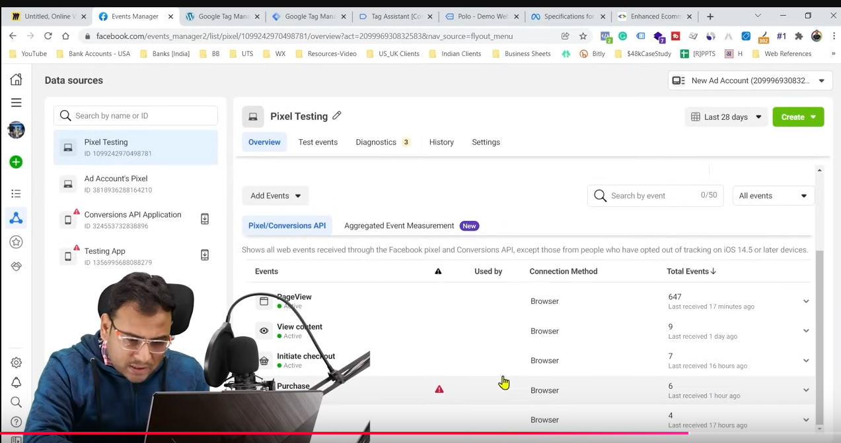

And then go to purchase event in the event list of our pixel

Now there are 6 events of purchase as shown above

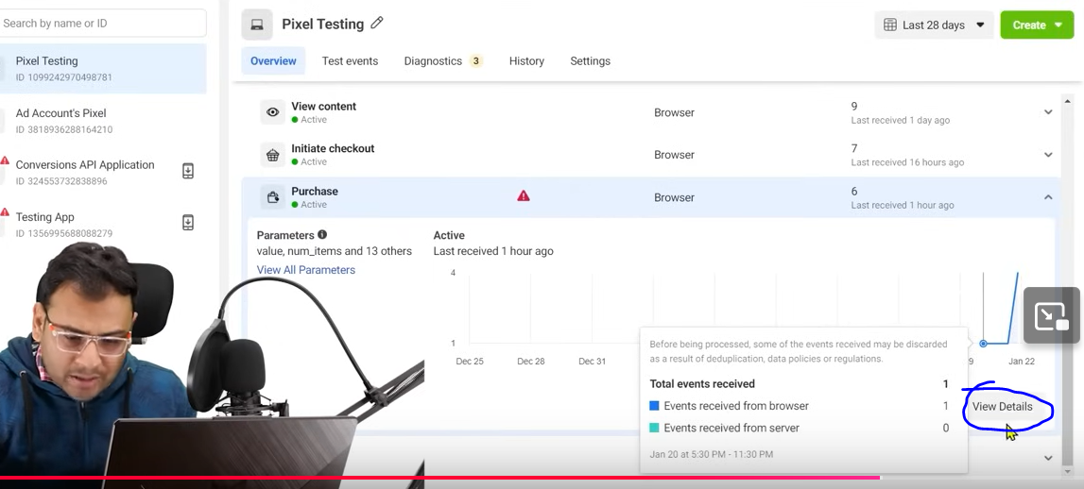

There are some events whose data is not given there information like Now if we click on the marked above area that is View details

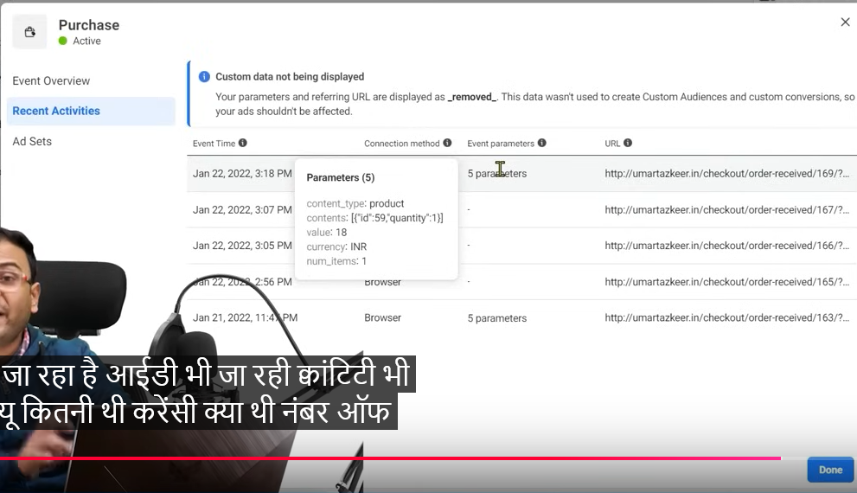

NOw yo can ee the event parameters containing there option in above screen

Give the code to developer so that theuy padte the code in the are awhener the purchase happens

By the way in CMS there are some plugins due to which thee data get populated whether we talk about wordpress, majento etc

Even if we did not add the plugin to our wordpress then wordpres website has its code

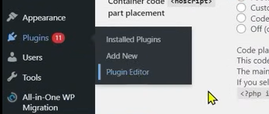

Now we go to plugins and then to Plugin Editor as shown above

Since the wholework is going on woocommerce then we need to edit the woocommerce plugin

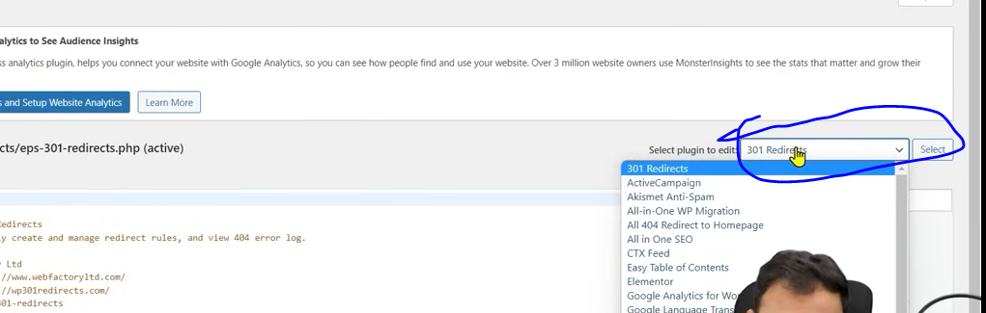

Now in marked area type the plugin to edit we type Woocommerce so we can open the woocommerce plugins code (which contains our pages) we will find the purchase code there and paste the code of parameter in event which we had seen previously there and modify such that they take the data dynamically

It does not matter If there is developer ad we have a backend access of our website then we can do so

Now we need to understand this point from starting according to different websites we habe to pick different event and configure them

Now in next lesson we will talk about the data we get in our data layer then how to use it with variables we can send the information to our event manager and along with that how our revenue information will go there

**Lesson 65:-**

In this lesson we will learn about **setup Facebook Purchase Event**

We want the information that will go to our GTM and then to event manager with that we also want the monitory value of things that are purchased.along with that we want to send information of our currency

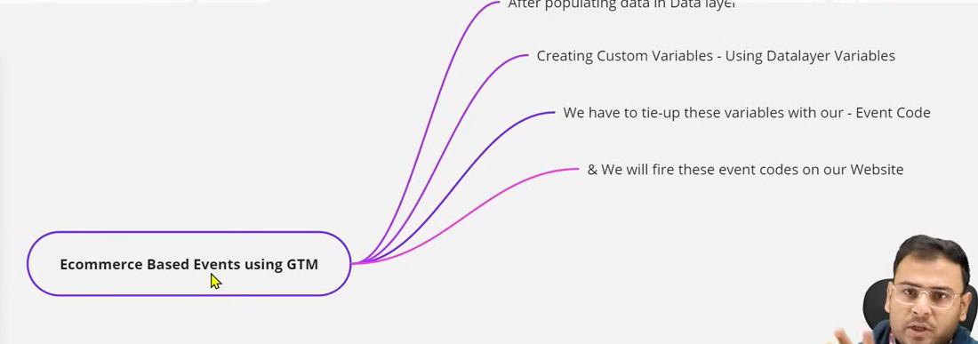

In previous lesson we give example of parameter but we have not fired any tag there so pixel helper will not show it

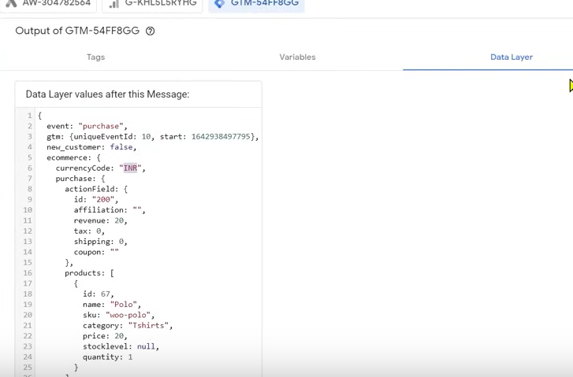

In our data we had seen our revenue of the product bought here and also the currency used information.

**Phase 87**

The trigger you make to do purchase by adding the function to the tag of gtm

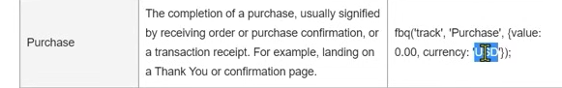

In function we need to replace 0.00 dynamically

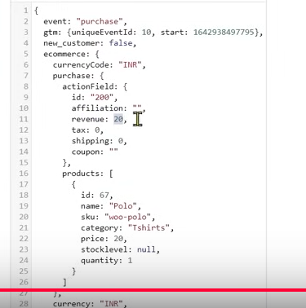

WE will make a variable on the basis of revenue so that any revenue will come in that variable

So as our data layer is populated then we need to make a custom variable using data layer varianble

Now we have to tie up these variables with our Event-code

Then we will fire these event codes on our website

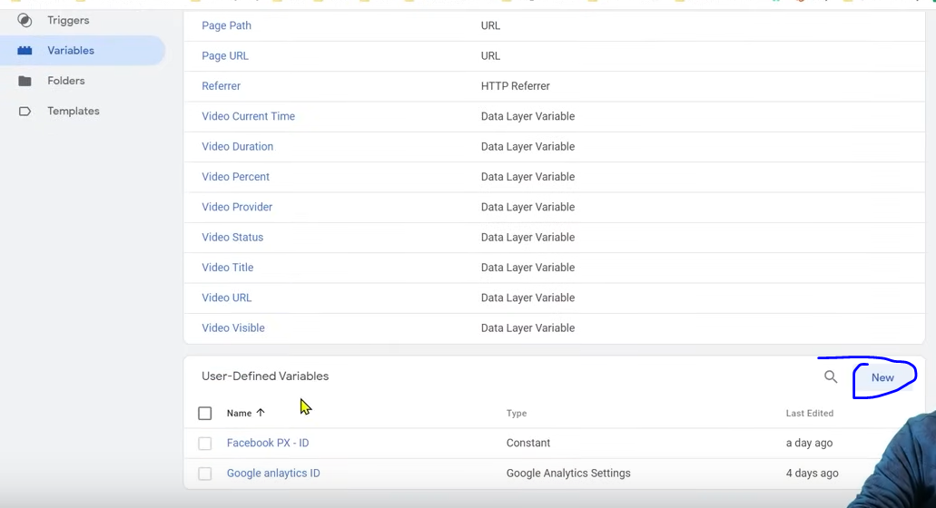

Click on the marked above area to create a new variable

Now how we will pick up the revenue

You cannot just type revenue you can

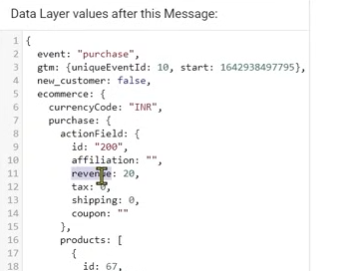

You have to type its full name which signify its location

Ecommerce.purchase.actionfield.revenue

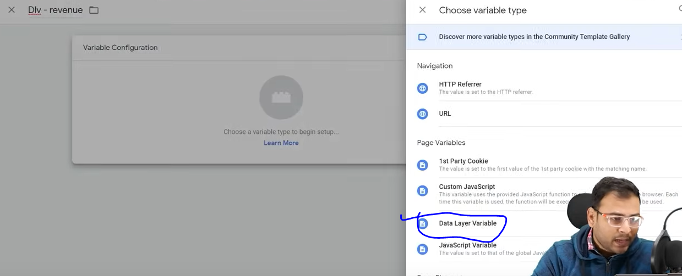

We click on variable configuration box and then a side menu will be opened

Now go to Data Layer Variable as marked above

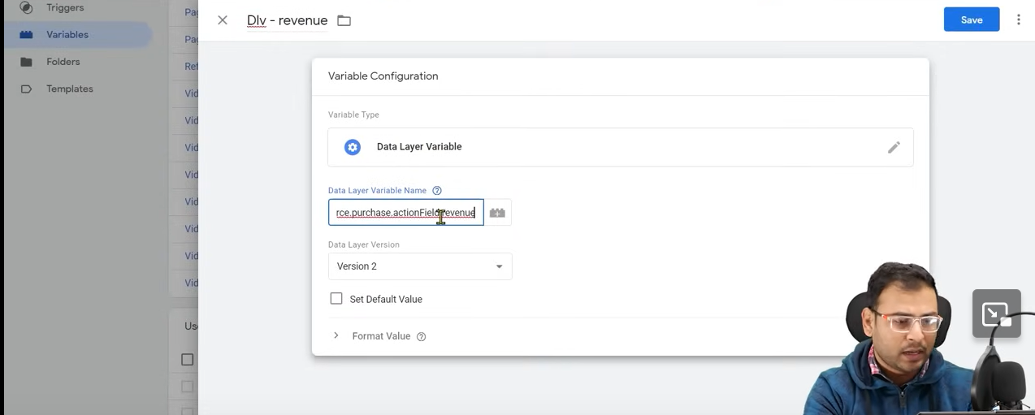

Now a new page opened as above type the name of the variable

Now save it

Now create a new tag

And in its code type as shown below

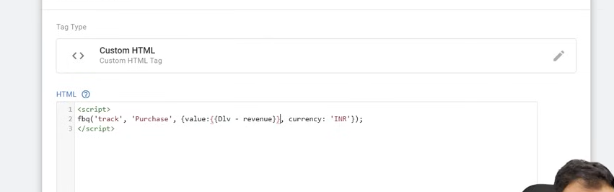

So from above we can say {{}}(double curly brackets) are used to signify a variable who will contain the revenue

Now when this tag should be fired

So click on trigger box

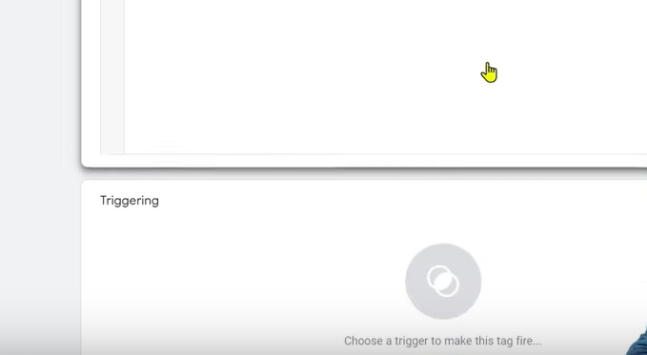

Now a side menu will be opened

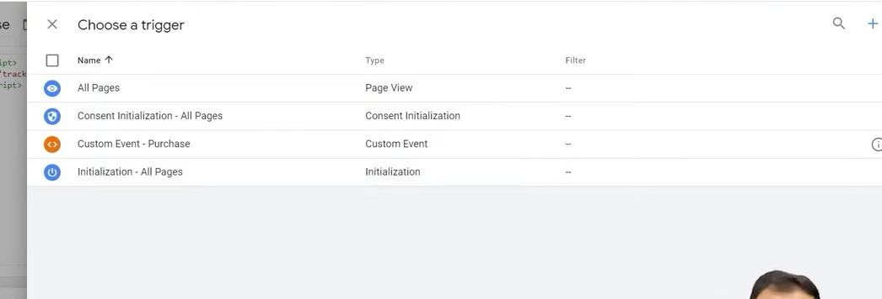

Now a side menu will be opened to choose a trigger

We choose custom event – Purchase which we had created in previous lesson

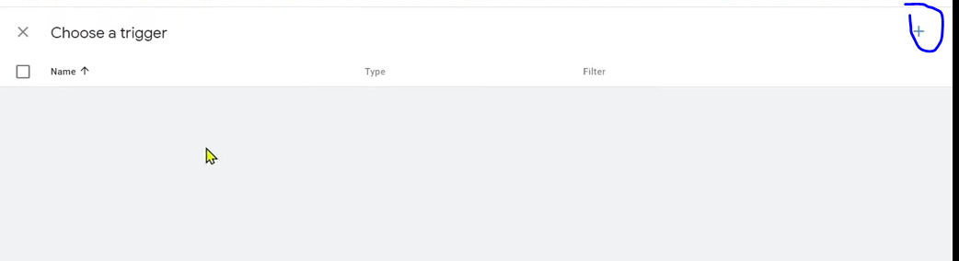

If you want to create a new custom event trigger click on + marked as above

Ame your trigger

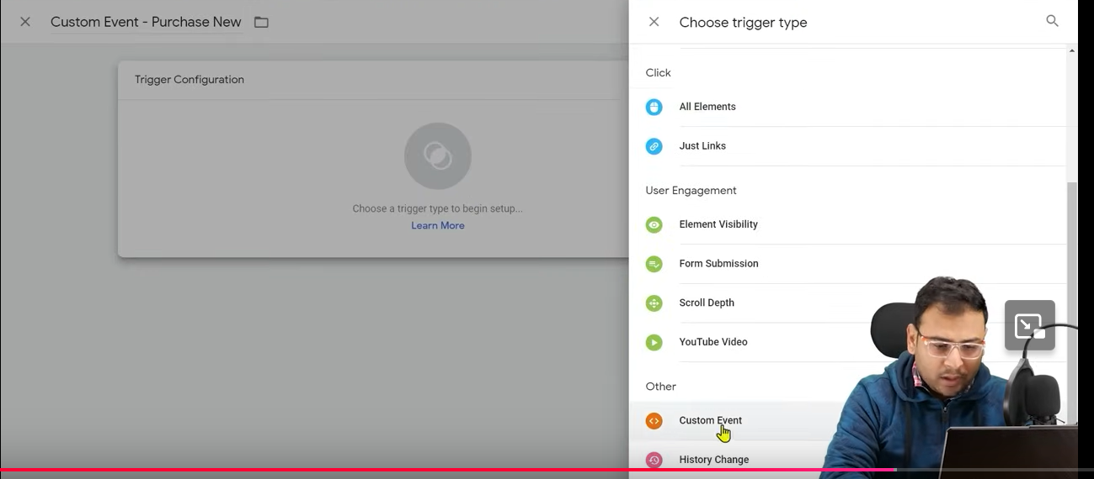

Snd then click on trigger configuration by clicking on block and then In side menu choose custom event

Name it purchase and check the all custom event s as shown above

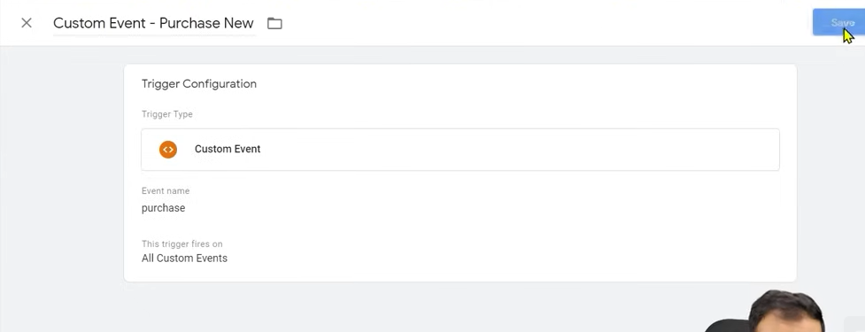

Now save it

**Note:-**

Whatever event happens is shown in GTM

Now when purchase happens

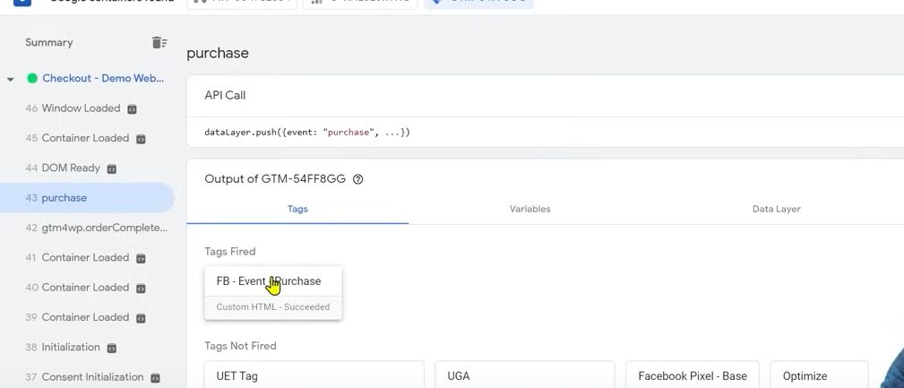

It is shown in GTM and also in pixel helper in Browser

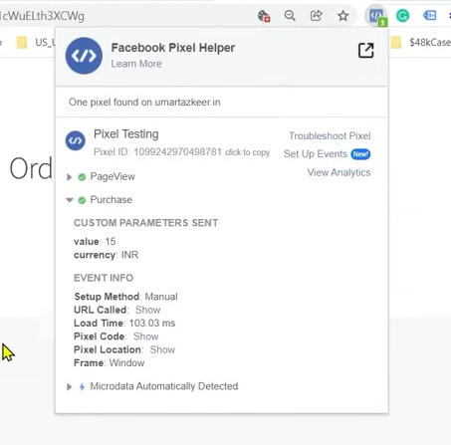

You can see that value and currency is given

Even if you needed another parameter you would have added another variable for it ad mentioned in the code as well

Event manager is like a data analysis tool

So we go to ad account whose pixel we have used in our website

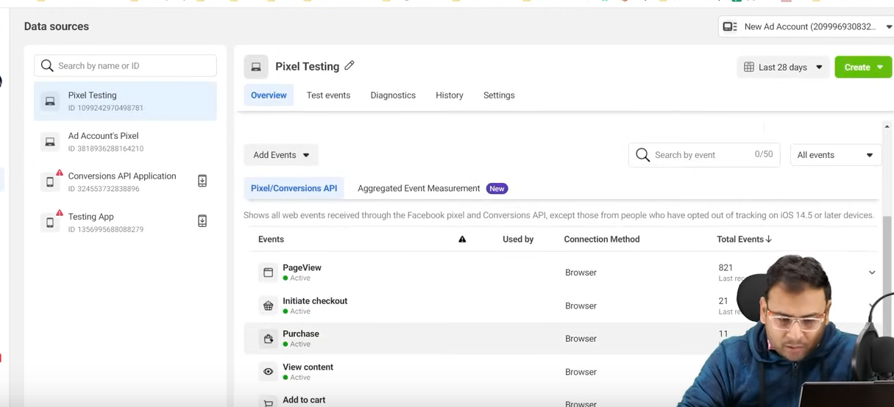

In evenets manager you can see your events are being tracked as shown above

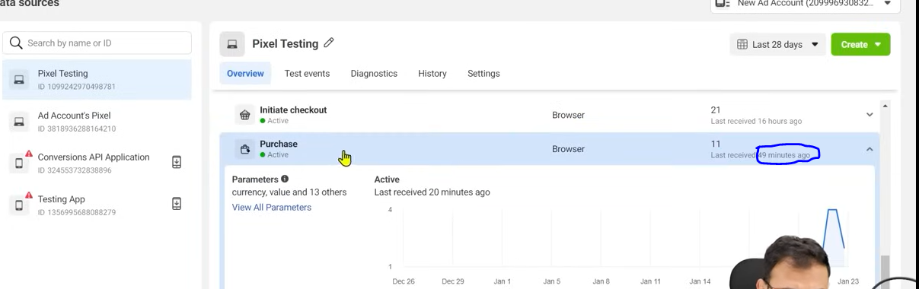

Now even you see above it is shown tracking happened 49 minutes ago

**Phase 88**

Now we see its details by clicking on It (and idon’t know how)

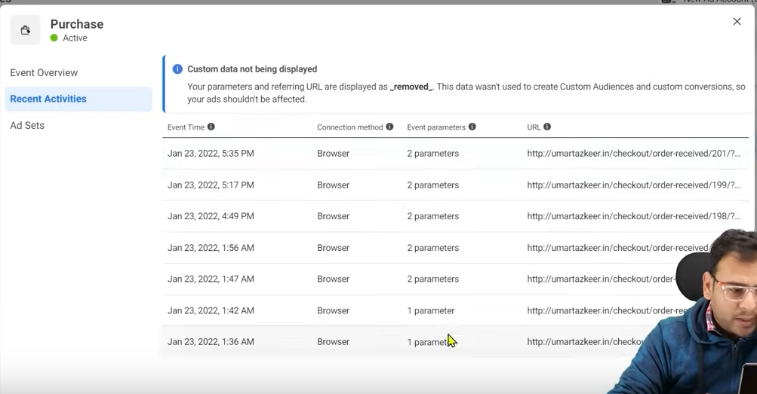

And if you go to Recent Activities then you can see the list then you will see that the parameters are being sent

That’s how you do ecommerce tracking

**Lesson 66:-**

In this lesson we will learn about **Facebook ads Spying and Research**

We are going to discuss that how we can see our competitor ad

WE don’t see competitors ad because we want to copy it . It measn we need to take ispiration or ideas from it not only competitor ads we can also see other ads

Means why we will see ads spy tools and see it and why we see competitor ads we need to understand this it is not that we see it when we want to copy something

You have also do many researches like you see one competitor ad and then see other competitor ad amd people working on that niche see their ad and when you have lots of information then on that basis you write your ad copy

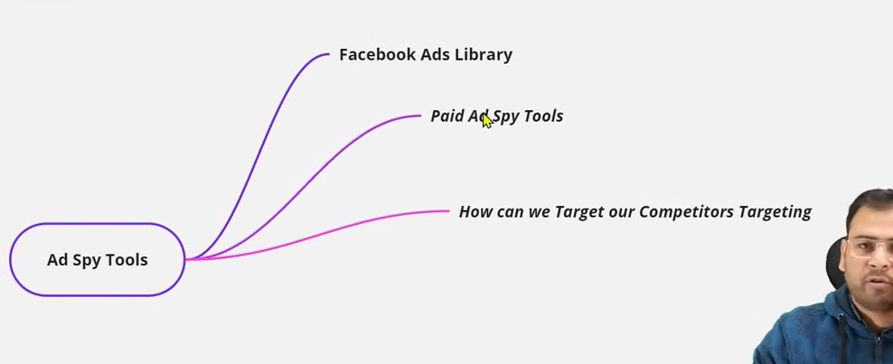

SO first we will see facebook ads library through which we can see many active facebook ads which are running through different pages its is free we can also call it Faceboook ads spy tool

There are vaious Facebook ads paid spy tol whihch give more information as compared to facebook spy tool

Third is that can we copy the targeting of our competitor The targeting done by our competitor can we copy it

TO copy that 100 percent is impossible

But by seeing your competitor ad or the people’s ad working in your niche by doing research about it and then you can find the audience closed to it

SO search for Facebook ads library

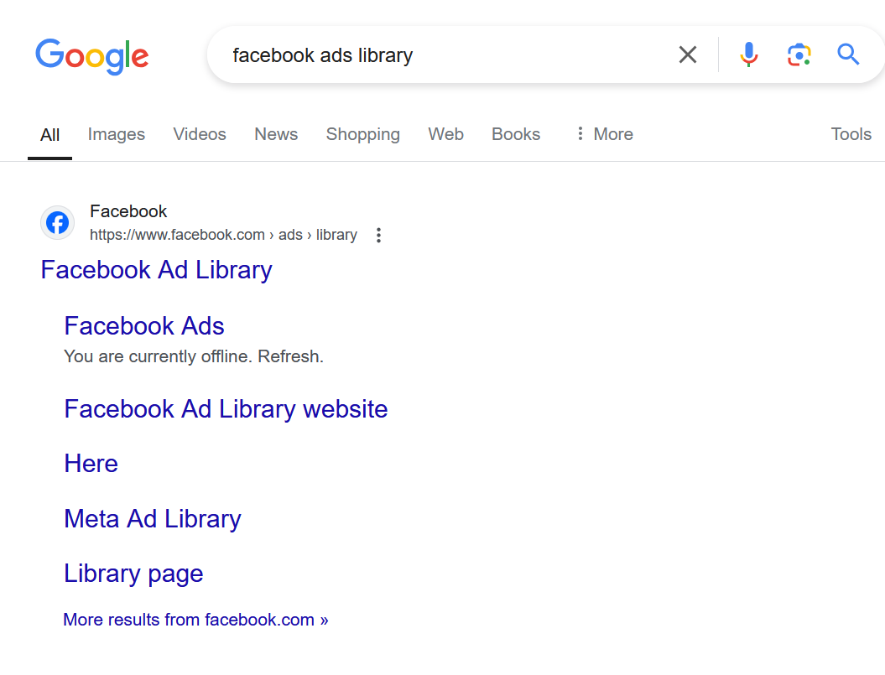

Click on the first link

Now you will see the page below

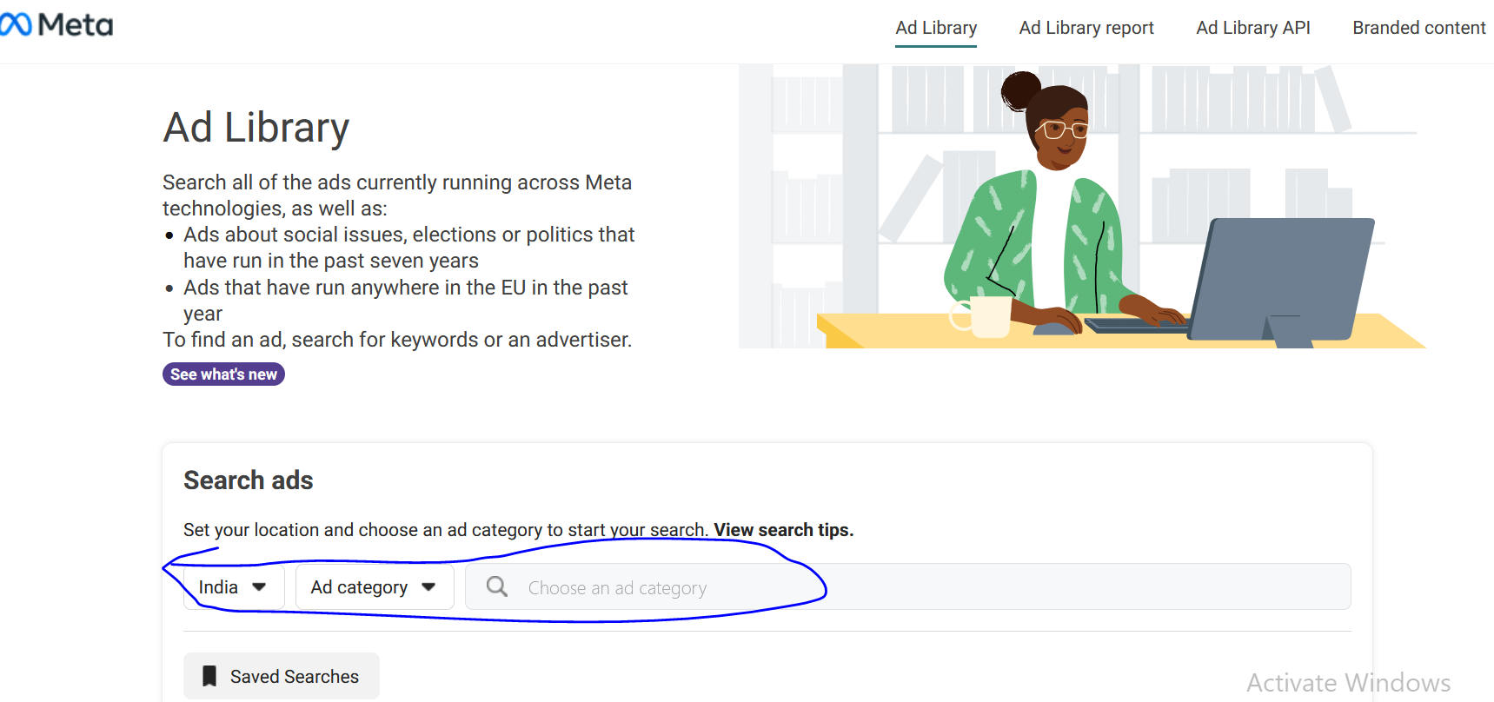

In marked area we choose India and then in second field choose All Ads.

NOw if we search Gym then we see the result below it

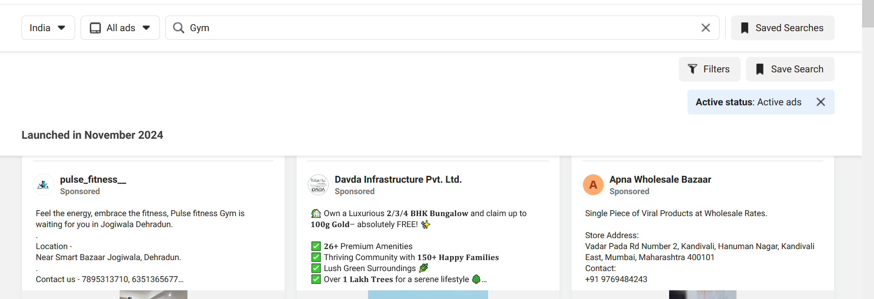

Here you can get the information of a particular ad like as shown below

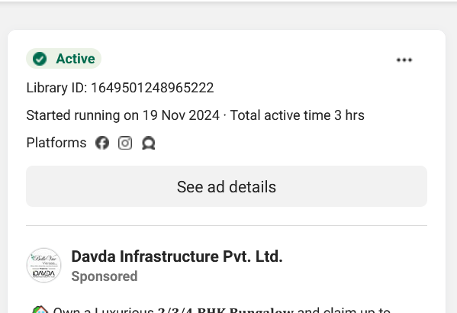

It is shown active and and it started running from 19 th November and it is running in facebook, Instagram and another platform I don’t know about

And it unique id is given Now if you click on ad details you will see the ad detail

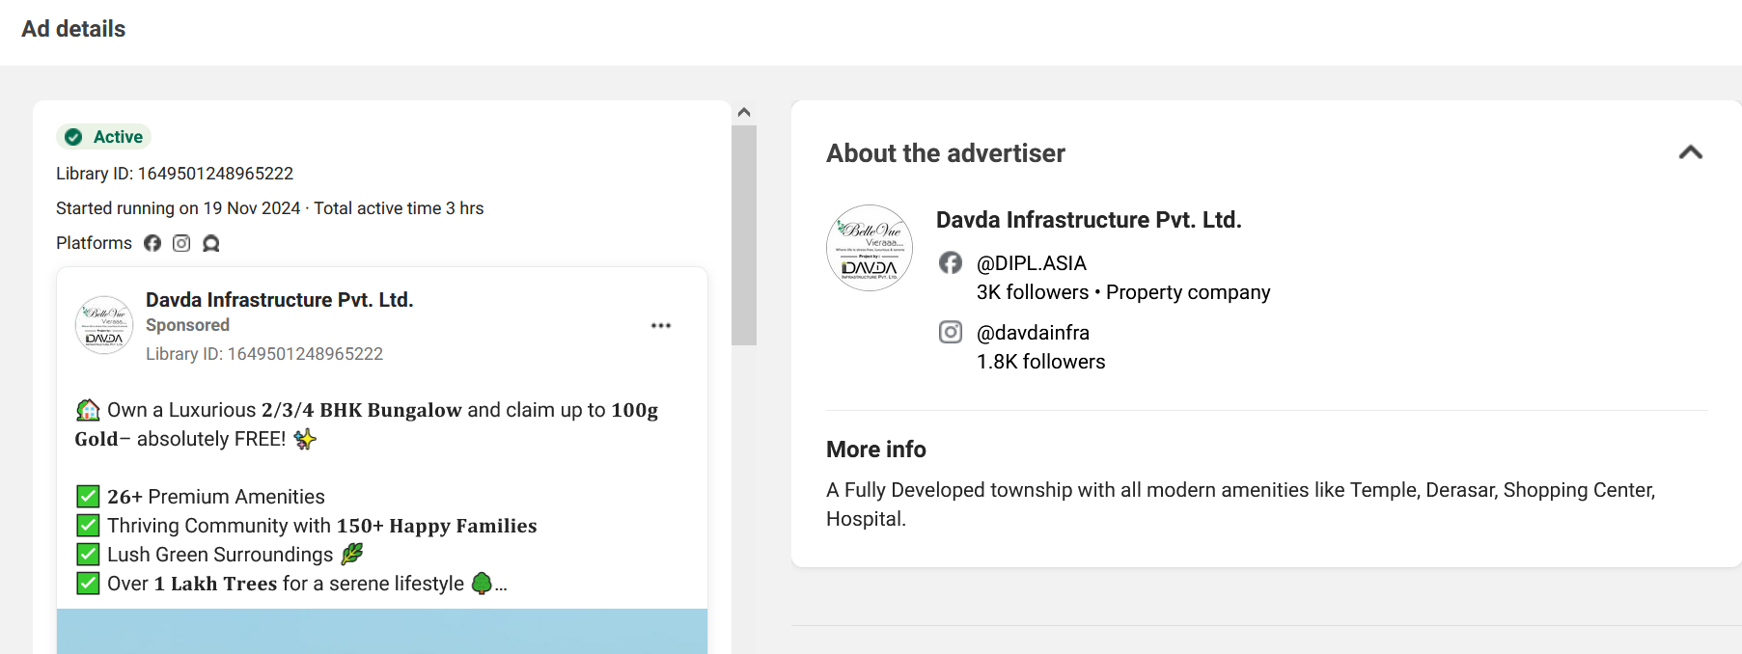

Now you can see the details

There are some paid tools like BIgSpy

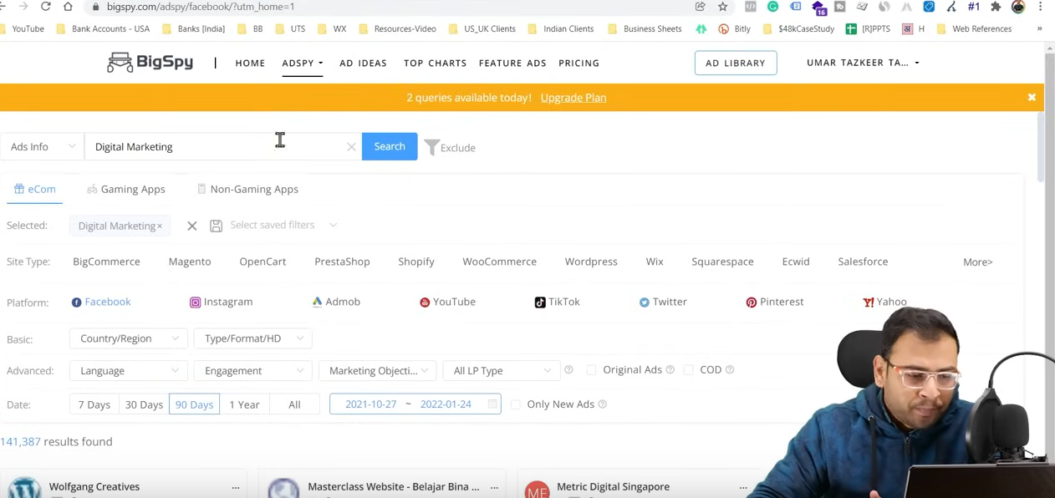

Since the teacher is using free version only two query is available

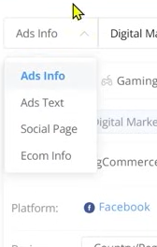

Now you click on ads info to open a submenu to filter what you want ot see

You can search it here you get many option to filter your result when you choose a niche then the tol or website related to will be shown , platform

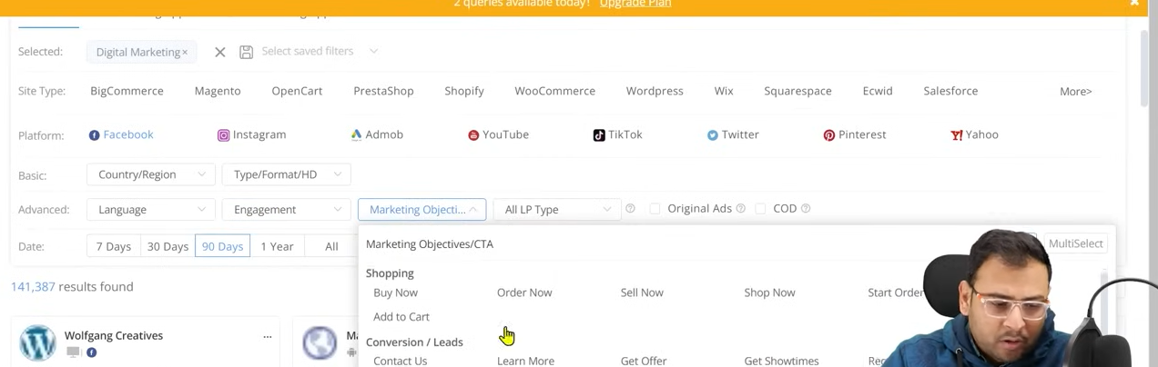

Above are the filter your search

You can even filter according to call t action or marketing objectives   
You see a particular ad more in detail like what was last seen what is the scene duration Howmuch tie has spanned since it is started running , How much popular it is

In this tool there is a particular index tp define its famousness which is between 0 to 1000

To explore further ads you need to buy it

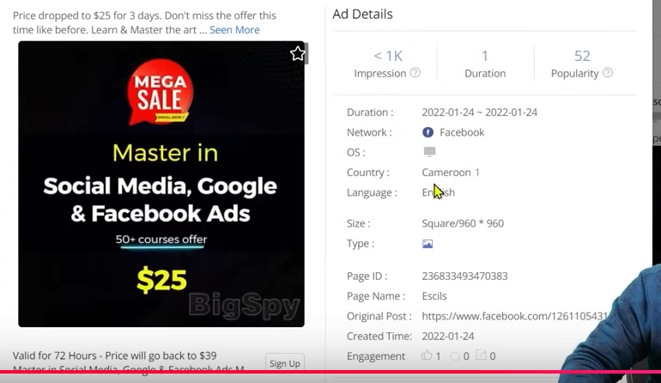

If you click on any ads then you can see the ads detail above

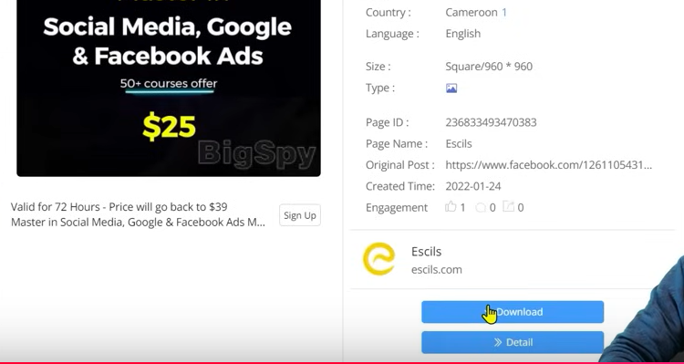

You can even go ahead and download it as well

But for that you need to buy it

If you click on details you can see its details

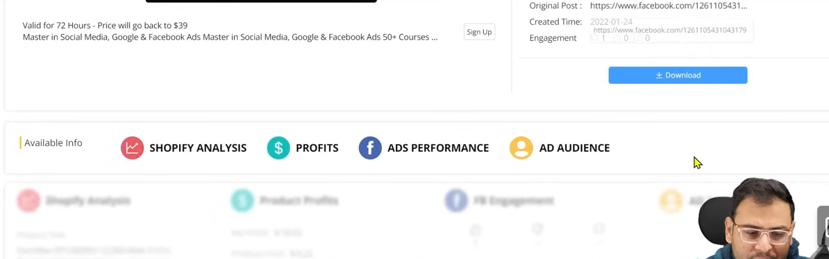

It is recommended when your ad spent is high and you have many clients and you have many clients and you do lots of research then you need it otherwise your work will be done by Facebook ads library

The third point we talked about is that can we target our competitor

As Teacher had said earlier 100 percent possibility is not possible but still you can do some research

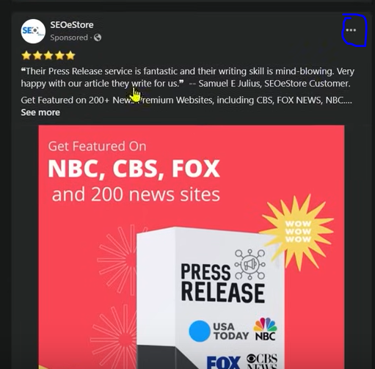

NOw suppose there is ad shown

You click on the marked symbol to open a submenu

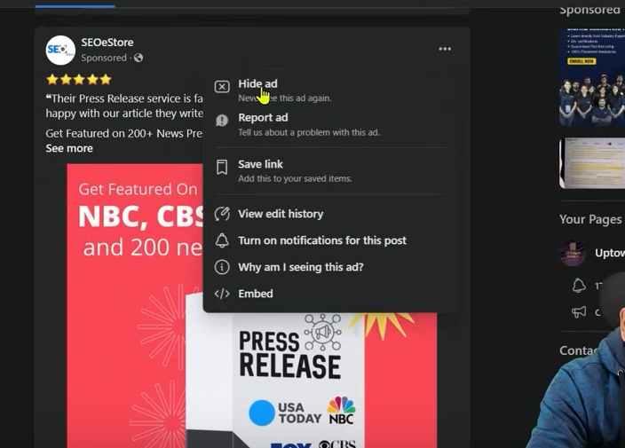

If we click on why I am seeing this ad

Then you will se the thing below

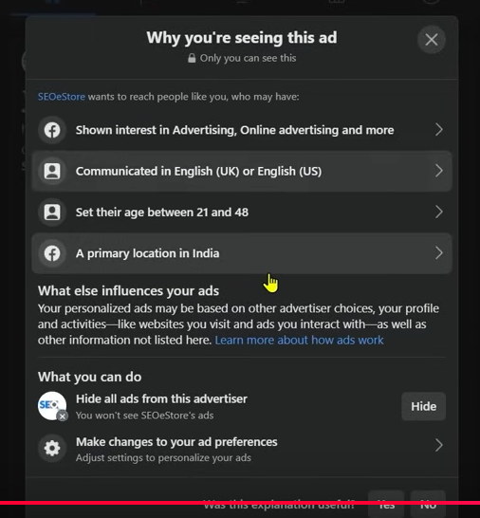

NOw you get the idea or facebook gives the idea that why you are actually viewing this ad

As you can see above that is is shown that I have shown interest in Advertising, Online Advertising now if we click on it it further explain it and it will show as below

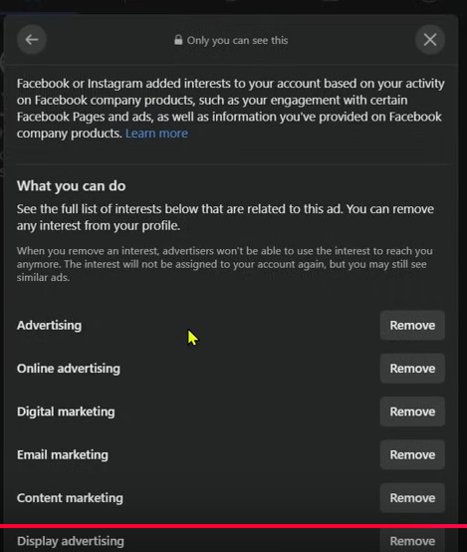

It is showing that we were interested in Email marketing , Digital Marketing

It can happen that due to this the advertiser is targeting the peole interested in these things and that;s why he can target us

It is just only on e factor



In above you can see another reason that is Communicated in English measn the language we communicate our age and because of our primary location in India It can haapen tat the advertiser had done the targeting this way It is not manadatory that the advertiser has done the targeting as same as seen above it maybe differnet but our interest slightly collide with it

You will not get all the idea just by one ad . you have to see many ad on the regular basis and you have to study about it then you can conclude that How I am being targeted now you get the insights and the targeting you see there and can use them when you are targeting cold audience in detailed targeting and show our ad to our prospect

Is there aby direct way that the way we are being targeted we can targete other on the basis of interest No there is no direct way There are just some research work on the basis of that you can do targeting and make a habit when you see that you liked an ad and it is relevant and its ad copy is good then you can save that ad by clicking on three dot as saved below

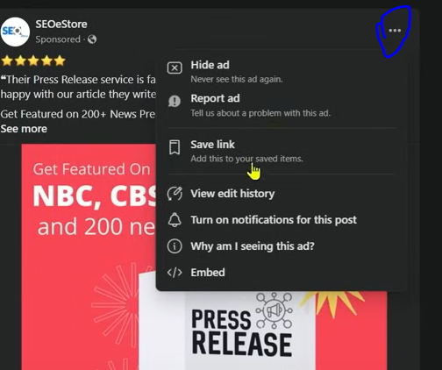

And then a submenu will be opened and now go to Save Link

And if I want to open it further in future

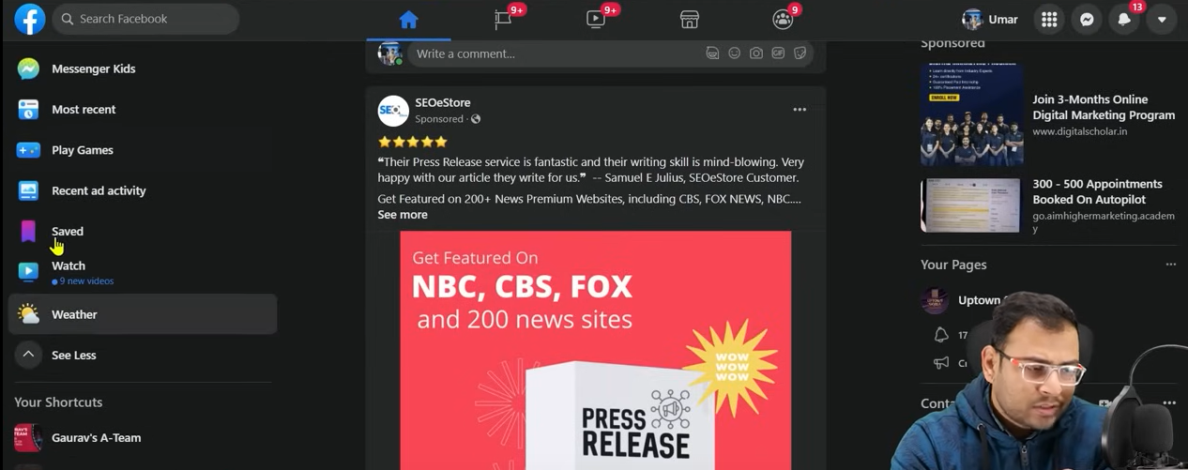

Now you go to Saved option in side menu we got here and access it if we want because you will not do the immediate research on it when you see it first time

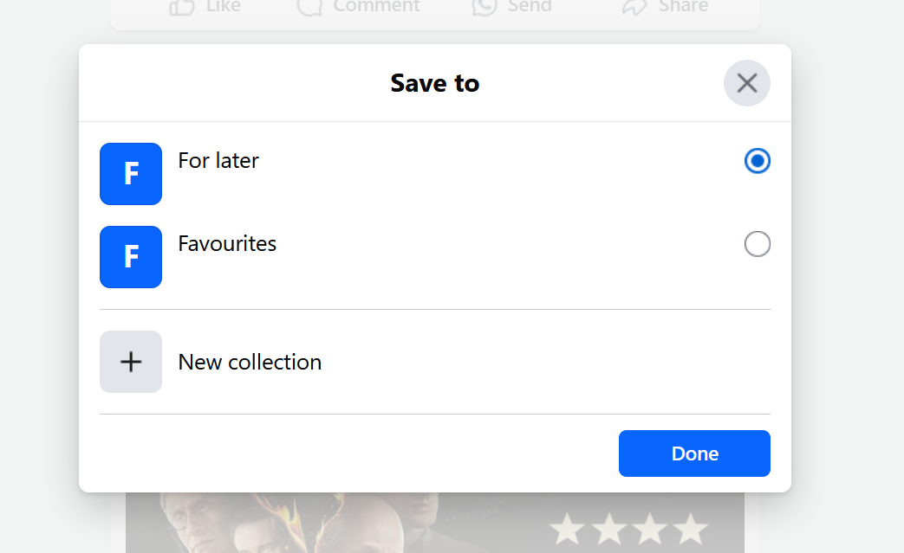

When you click on saved link you see above choose your category where you want to see it now click on Done

It will be saved in that category

**Phase 89**

These are the small things that you will not feel that they are helping you directly but if you keep habits and do these things then in long run when you run ads then they will be very helpful to you

**Lesson 67:-**

In this lesson we will learn about **Catalogues in Facebook Ad**

In older version when we used to select campaign objective we chose

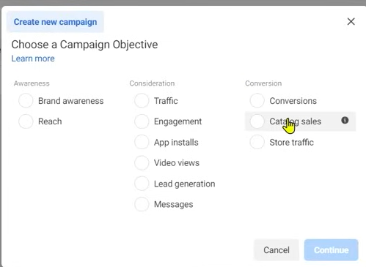

Catalogue sales as shown above (maybe it does not exist now)

Whenever you try to create it

It will ask you to first create a catalogue first. People also call it shopping ad because it is majorly used in our ecommerce website

Now there are three or four website will come in front of us. That I what is a catalog

Then we will see how to create it.

Third is if we even create it then how our catalog will help us. We will discuss it first

First now we will see what is catalog

Caltalog is a feature which is used by facebook ads under commerce manager Inside facebook ad you see many options like the option to manage pixel is in Event manager in the similar way facebook gives us an option of Facebook manager and here you get the option to create catalogue manager In our website if there is a product then it has some attributes like every product must have id, description , price . SO type of product we have in our website we give there information in the form of feed to our facebook system that’s called a catalog

There are different ways through which the product in our website we give them to the facebook system in the form of catalogue NOw how we take it it depends on the technology of our website . if you are in wordpress then the work become easy . If your website is custom you say to the developer to make us its feed and then we download it and then these peoduct with their information while creating catalog update it then there is a thing called commerce manager

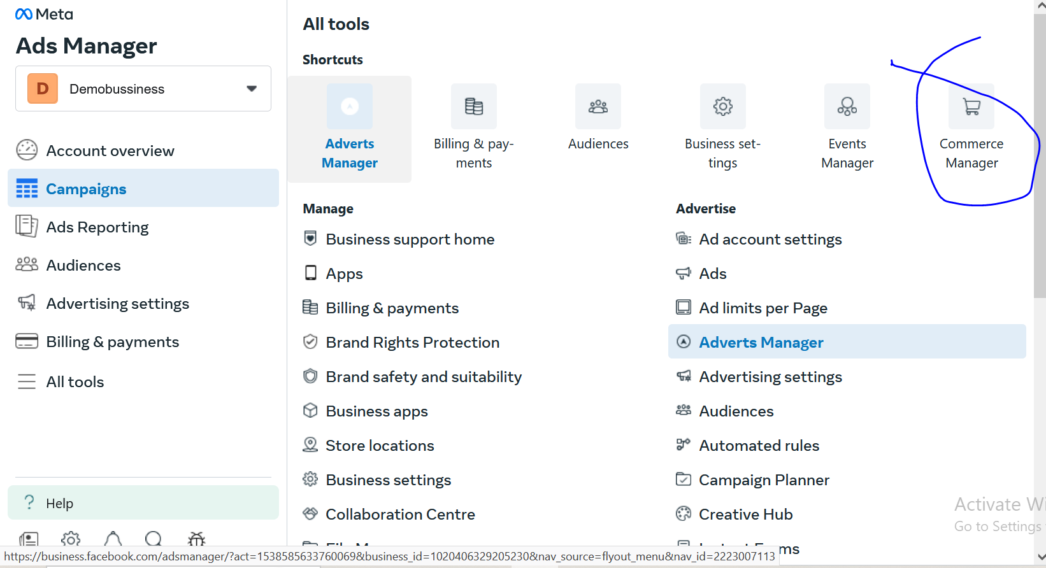

GO to marked are to open Commerce Manager

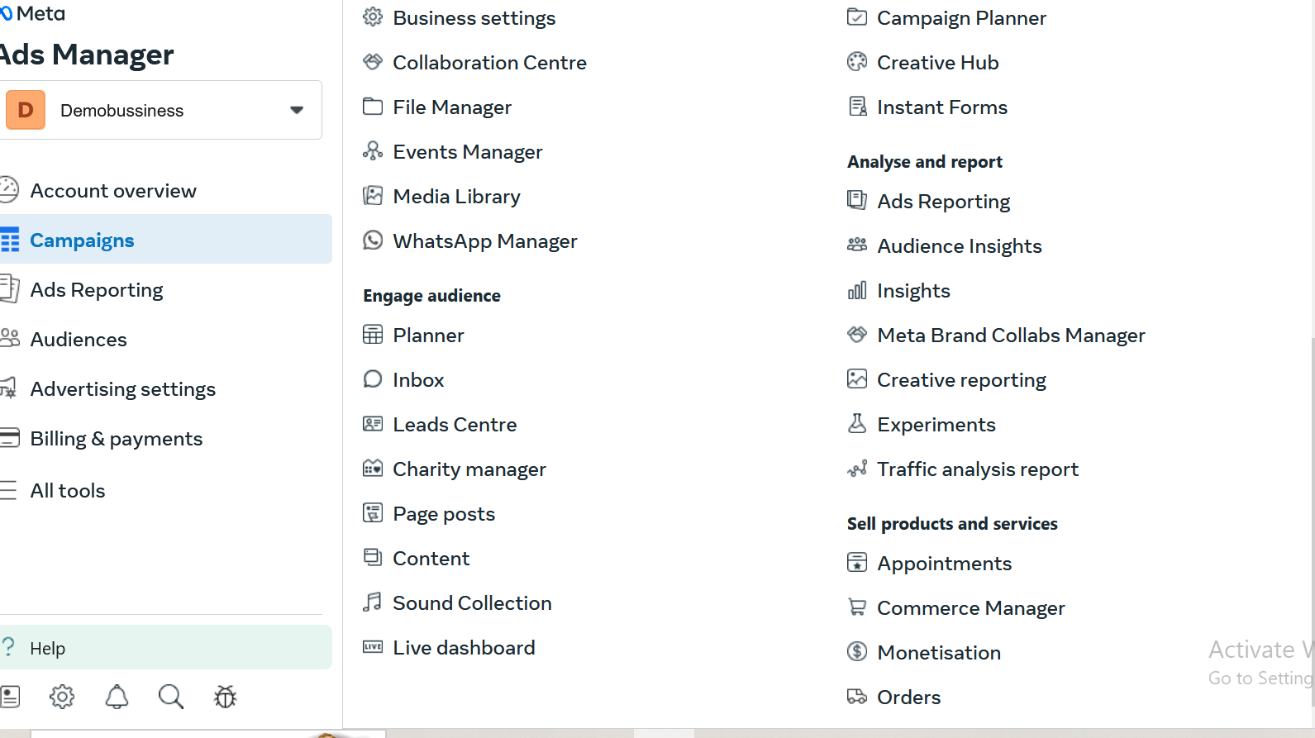

It comes under Sell Product and Service

If your website is Ecommerce nature then you will need commerce manager

I have not added any product so we will see from teacher perspective

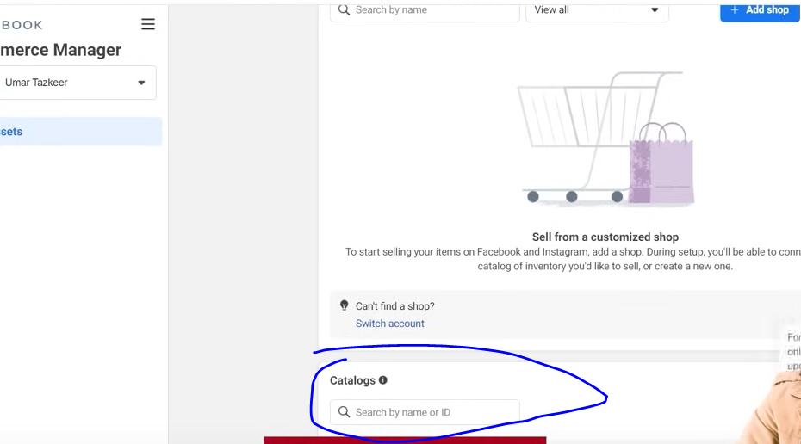

It will give option to create a marked area as marked above click on add catalog button and then in new page

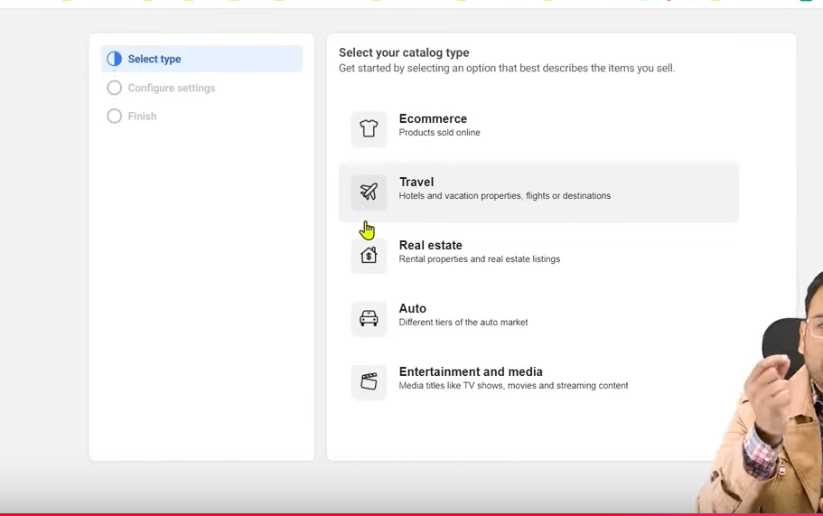

Now the UI will look like above

NOw what type of catalogue you want to make, what type of product you sell on the basis of that you keep information here

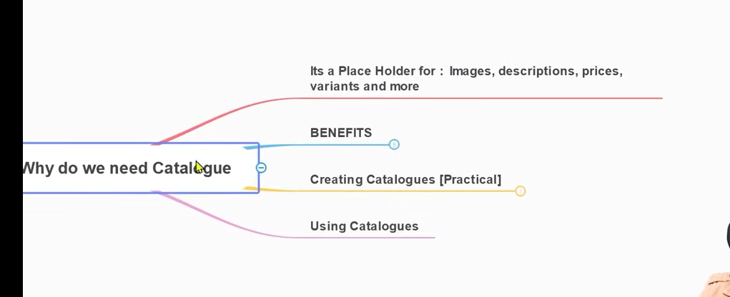

SO now you can understand that catalog is a placeholder where you upload information related to the product to the catalog . Facebook system shou;d have catalog containing information related to all your product

Can we run our ad without it if yes then what happened that we need it to run ecommerce ads or cataloag sales ad we have to form catalog

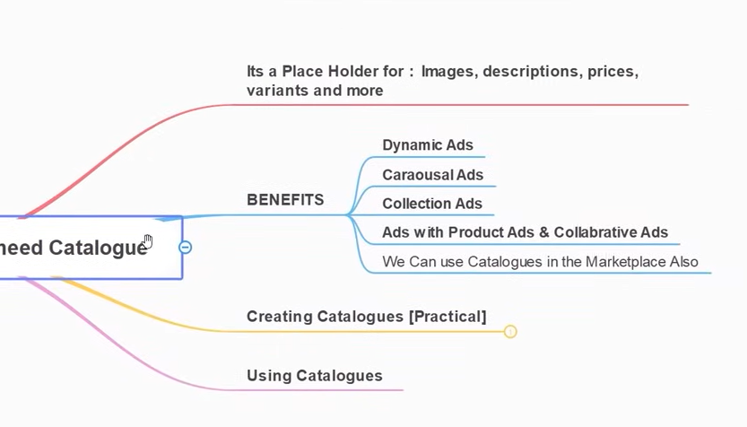

Now we talk about its benefit

First benefit is dynamic ad it is thing for which our catalog are mostly used

What is dynamic ad you maust have experienced it once if you have used internet

We will see what is our dynamic ads approach and how catalog play an important role in it. We will do discussion around it . you must have gone to many website

Suppose we take a website and there are many product there and every product have unique id sand every product have had its product page and every product have its pages loke add to cat and checkout Now suppose you go to product 3 and then we add to cart it After you do add to cart when you go to facebook and there you see the sasme product but with some offer

Now in original website it was showing 1000 in original website and now you see it in facebook with 10 percent discount Now the user will see that he is getting discount here so he buy it that’s how a marketer increase its sale

Now similarly if another user like a product and then add to cart then they will see it in their feed and see product similar to that category whose product you liked or added to cart

By what way the facebook can understand that one user interact with one ad and anpther user interact with other ad. Means facebook system has an information what are the product user interacted with it

This all means that the information of each product is inside the Facebook system

If it does not have that information then how did it match them

The person goes to that product how the information goes to facebook

Now we assume that all this information will be kept by the pixel itself now pixel send this information to facebook now facebook system should have some list on the basis of it matches it and so that ad related to that product to the user who interacted with that product

It means for the sake of comparison facebook has some form of Information

That information is catalog or the source of this information is catalog

So basically catalog is a data source which keep the information of all your product present in the website

Now if user see the product interacted and it has an id suppose 1 then the information goes like that product number 1 is visited or specific product id is visited then the facebook check that in its catalog the product number 1 is that now we will show this ad to the user or products related to that product category ypu interacted with it or whose id is 1.

**Phase 90**

So actually this is dynamic ad the product we saw in a website we see it in our facebook ads

We talk about remarketing but here we are talking about Dynamic remarketing measn we see a pen we see in facebook we see any product in a website we see it in facebook and other product related to it and now in normal remarketing what happens is that who come to this product of our website shw them this ad we are manually doing it by this way a website has 1000 product we cannot target them manually it is actually not possible so here we need dynamic ads in which the user sees the product in a website and they see the product ad in the facebook dynamically so they are dynamically being targeted

So that thing show ad dynamically the facebook should have product information. That information we send in facebook that is actually called as catalog that;s why we need it

Now if your website have thousands of product then it will take a lot of time to send the product information to facebook

Because now if you see itd formation



If we go to next step

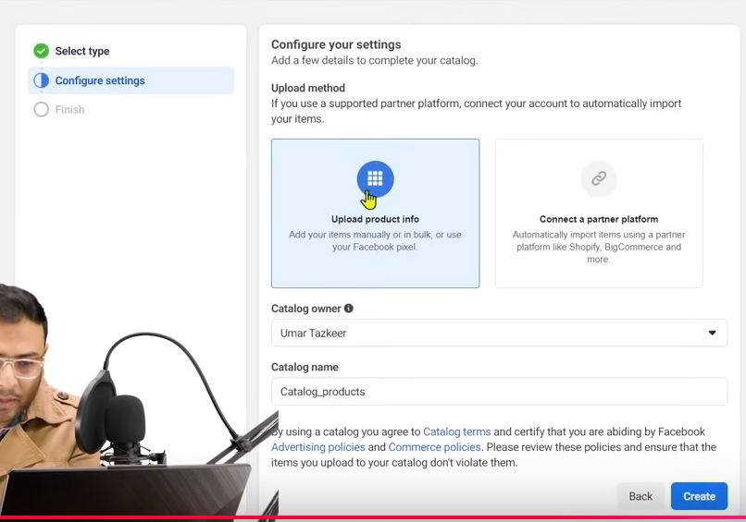

Then you can see above window asking you to enter the information of the product as shown above

Now if you click on Upload product info then it will give a list which we will discuss while catalog creation The list is basically telling you to give this information about the product here and mentioning them will take a lot of time

SO now here comes the concept how we can create catalog

Load 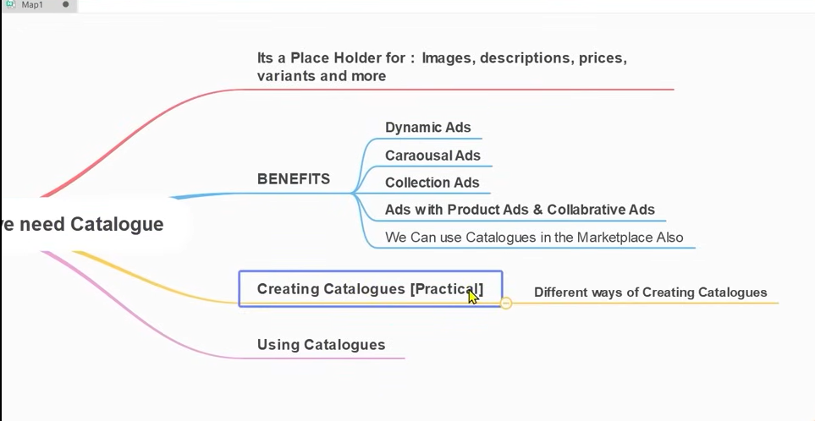

Now there are different ways to create catalog depend upon what type of website we have but we will not do it manually we will do manual if you have two or three website but if you have thousands products then it is not possible we have to do it automatically it should be like that we download all our information and upload it . This process we call it as feeds

The second benefit is carousal ads you see and then in these carousals the ad put by the advertiser are dynamically fitted and they information they get is from catalog because catalog has already have information of catalog. Now you don’t have to make ad for the product separately that this product has this price etc these all information we dynamically got from catalog . SO your all product information is present in catalog . The product related information we see in the ads that information we wil not get from the website but from catalog

These are the advantages and benefits of catalog

WE can run collection(catalog) ads

We can run product tag ads and collaborative ads

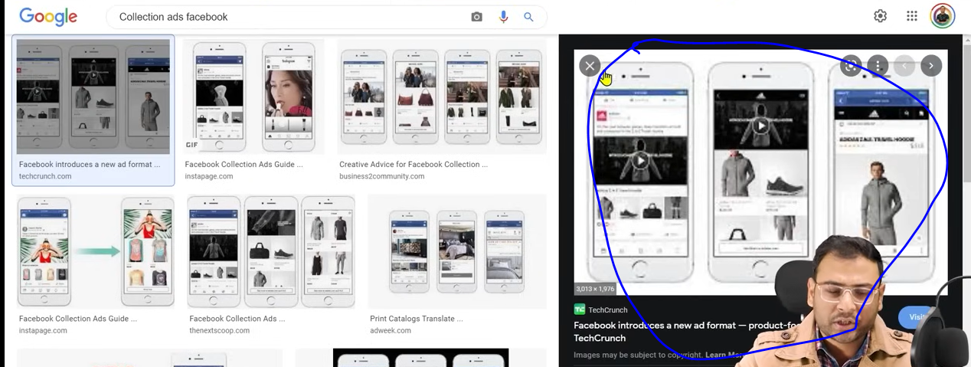

The marked above is the example of collection tags o if the person click on any of the product then they will reach its page and all these information are present in Catalog.

Catalog Is managed in commerce manager

Now if we want to create a catalog then ho we can create it



Now suppose we choose Ecommerce and then go to next button

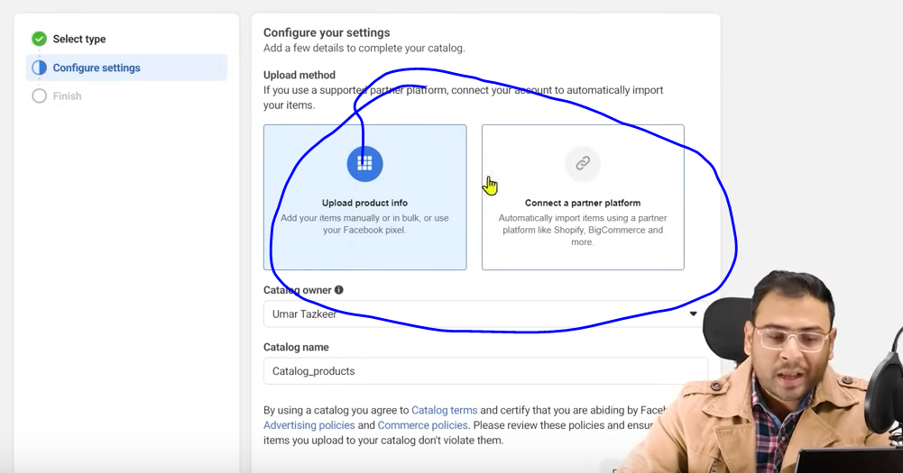

And now in new window go to marked area you can see two option one is to manually product info and the second is that Connect a partner platform.

Partner Platform is like shopify, Ced commerce or other ecommerce making framework through which you can make your ECommerce Website you connect to them and then directly your product information will be imported there but we don’t do it the reason behinf it t=is that we manually upload our product information because when we talk about product attributes then every product have some attribute

Now rhe product may have attribute like title, description, image etc NOw if we manually download these information and then upload it then there is a scope that if we want to change it then we can change it because next we have to understand that when we make catalog then what are the best practices that we must follow because catalog has this product information and it tell us organization about how we need ot keep our description , How to write title , and what are there product information Now to follow these practices we want htat control should be in our hand we don’t want that connectivity happens or direct connectivity happens

Now in our catalog name field we tell about Catalog name

In Catalog owner choose the product owner. Like we can share pixels and we can share ad account access , like we can share our pages. Similarly we can share our catalog

Now click on next button now the window will look like below

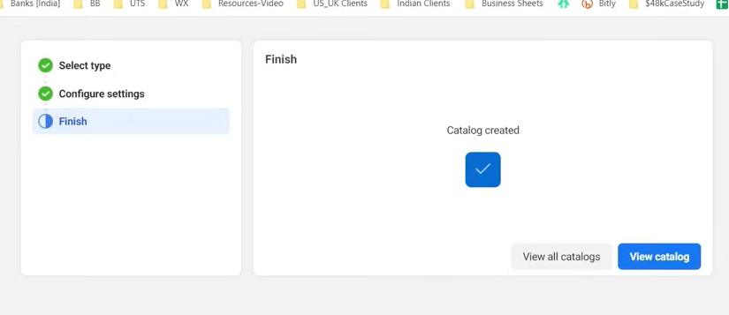

You will see the message of a catalog created.

Now clikc on view catalog

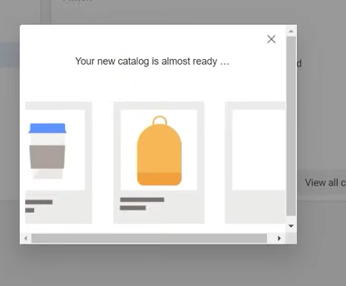

You will see above

It will direct you to commerce manager (maybe)

Now important point is that you need to add products here

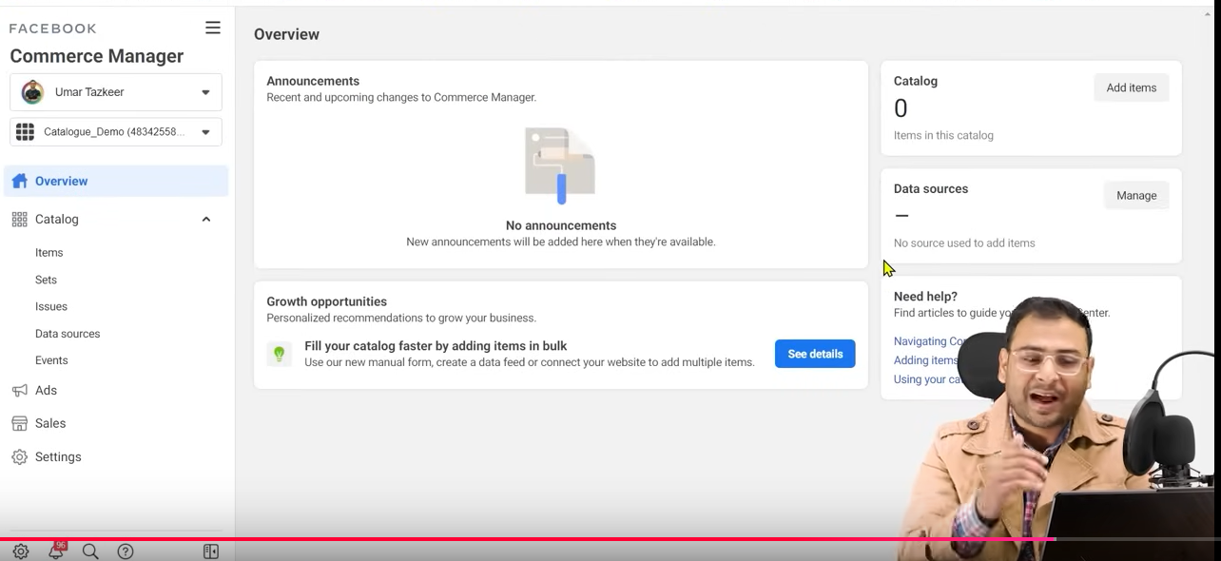

NOw our catalog is formed as shown above

Now if you add product then we may get the error and they does not add correctly or you add a product thst is not allowed by facebook or you try to run ad which is against the facebook policy in all thoe cases it will reject your products

TO manage all these things facebook ahas separately made Commerce manager where we see our catalog section

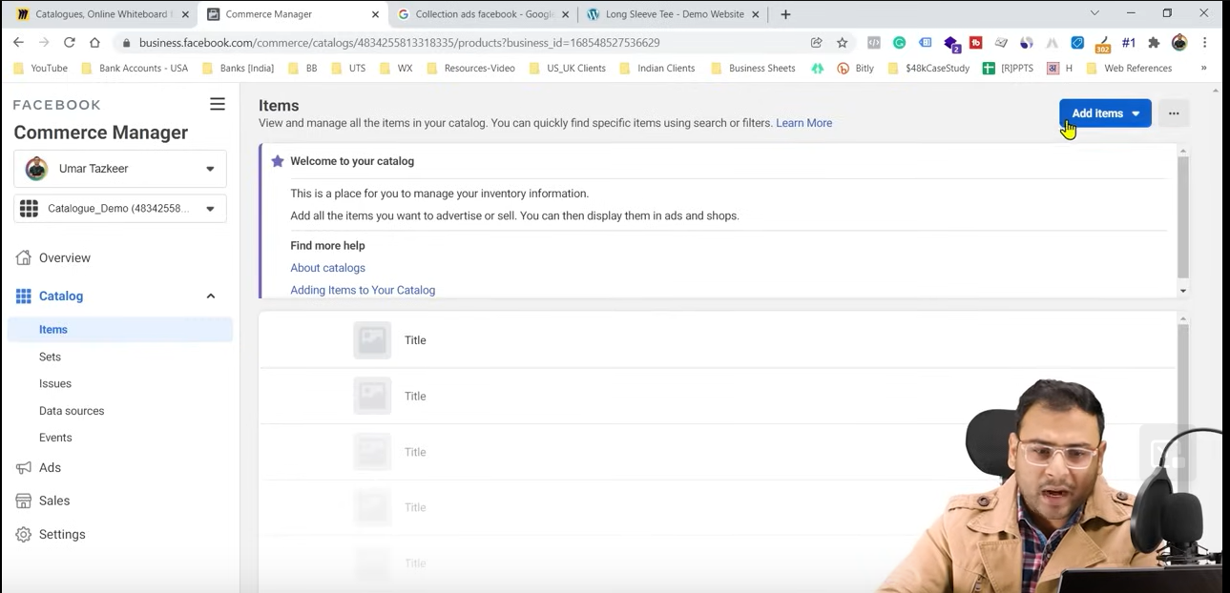

NOw if you go to items in ide menu and then you go to Add items

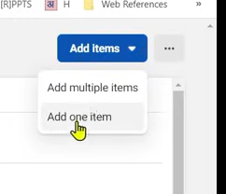

And then a submenu will be opened

Now we click in Add multiple button Now it will ask many questions like below 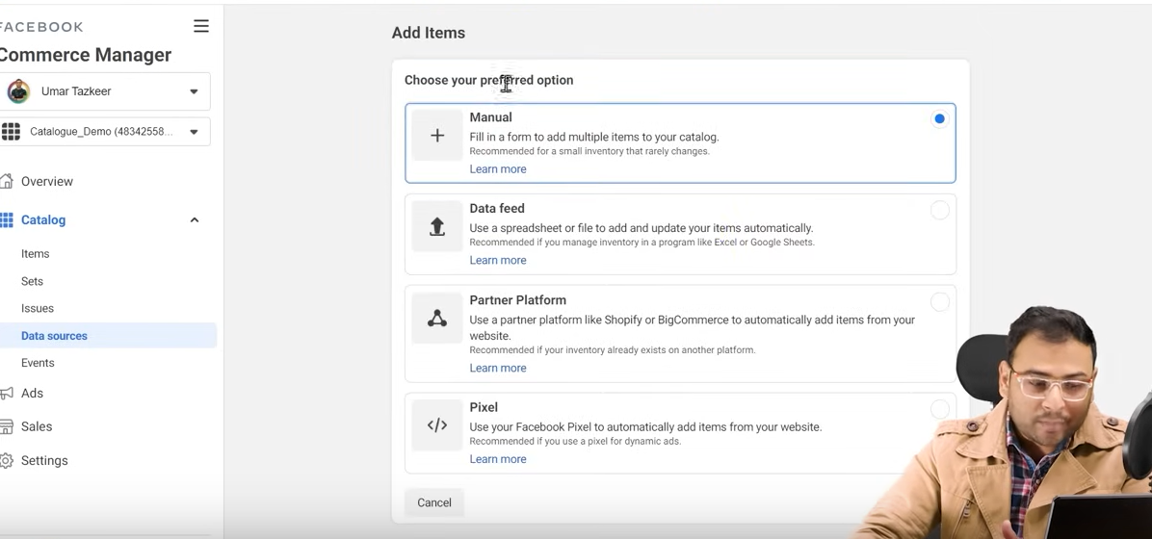

That by what way the product in our website you want to bring it in your catalog

Whether by manually , Data feed, Partner Platform or by pixel it is like uploading in bulk



Bu now if you click on Add one item

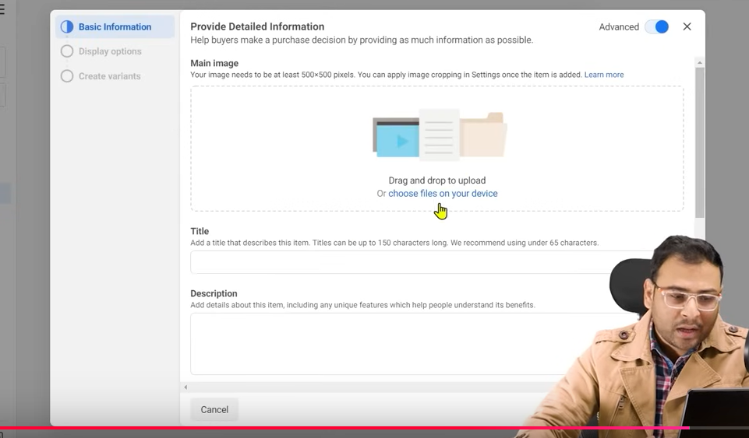

It gives you one by one uploqding facility as shown above that we don’t need it basically because it is very rare that an ecommerce website has three or four website but if hteree are then menually is good way to do it. Then you will not waste your time and you can keep your attributes u=in your way

Now there are many attributes like Main image which you will see in the ad, title of your product, description

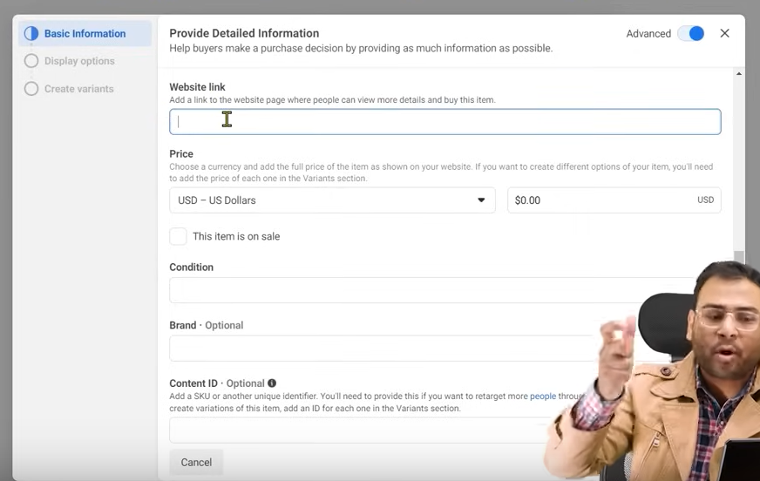

Website link mean product link that is related to the product when you click on it to explore it

,price of product , condition of product is it new ,refurnished, you have ssen different different type of products

**Phase 91**

especially in amazon and it comes under which brand and what is its content id 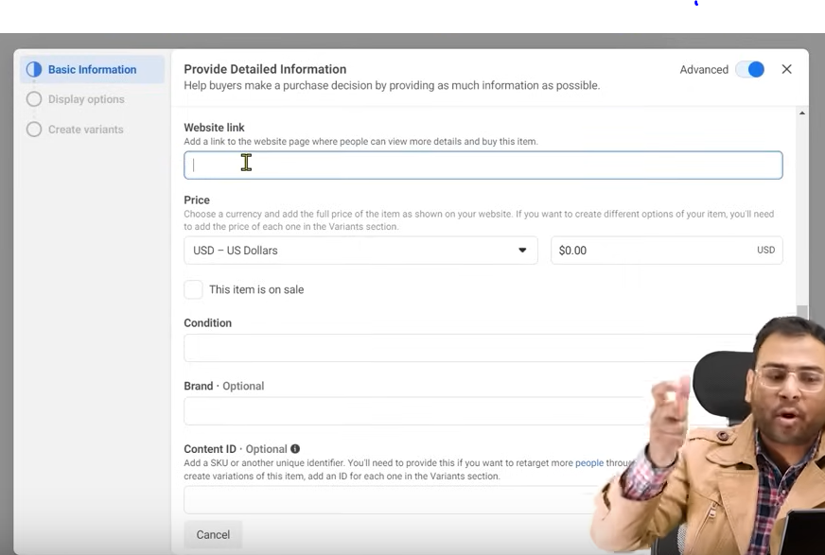

and now after you click on next it will show Display option

There can be many variants like in size or color it take those information(maybe in display option (who knows))

Now catalog is basically information of your product on your website If you want to run ecommerce based ad or catlog sales then you have to make a catalog

We can even use catalog in Market places to show your product dynamically

Now catalog has your information they can use it anywhere you want

We can even use it in shops functionality present in Facebook and Instagram.

But shops option are not present in All countries

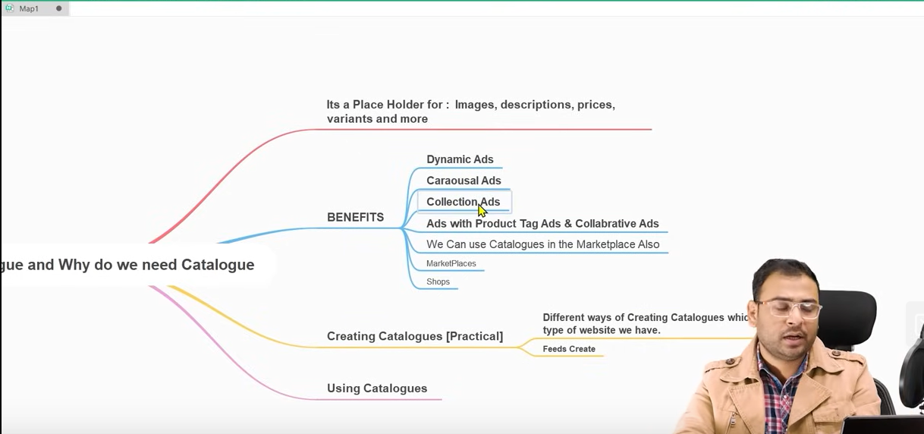

**Lesson 68:-**

In this lesson we will learn about Create and upload Product feeds in Fb

How to create our feed in many ways and how to upload it in our catalog so that our catalog get populated with our product Unless we have don’t have products in our catalog we cannot run it

So now you have to first create a field , upload it and then make sure that The product does not have any errors If you get errors then you have to resolve it and you have to keep the product active and make the catalog ready to run ad for catalog sales

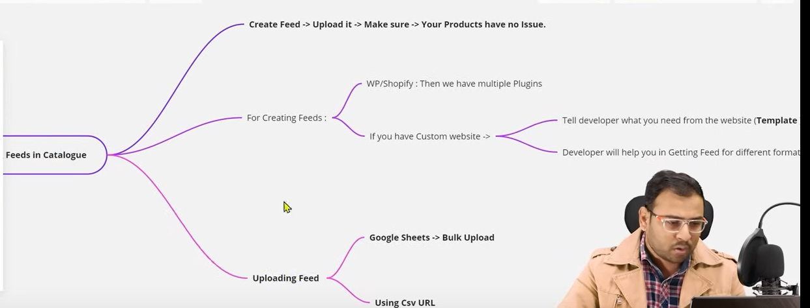

By creating feed we mean that we get product in our products in set format it is actually a feed

How we make feed depend on the technology we used to make a website

If you made the website by wordpress then it can be done by the plugin or if it is made by custom then you say to the developer that you provide all the product in the form of feeds to

Now he will ask you what is feeds and then you say it look like below

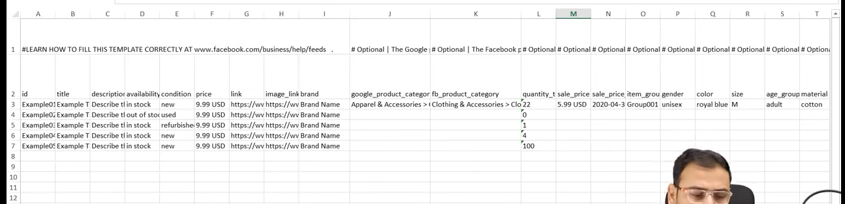

This is a demo field downloaded from facebookn by the teacher . Teacher will tell us how to download it

You will say to the developer that our product have attributes like id, title, description etc and there are given in our website aas shown below

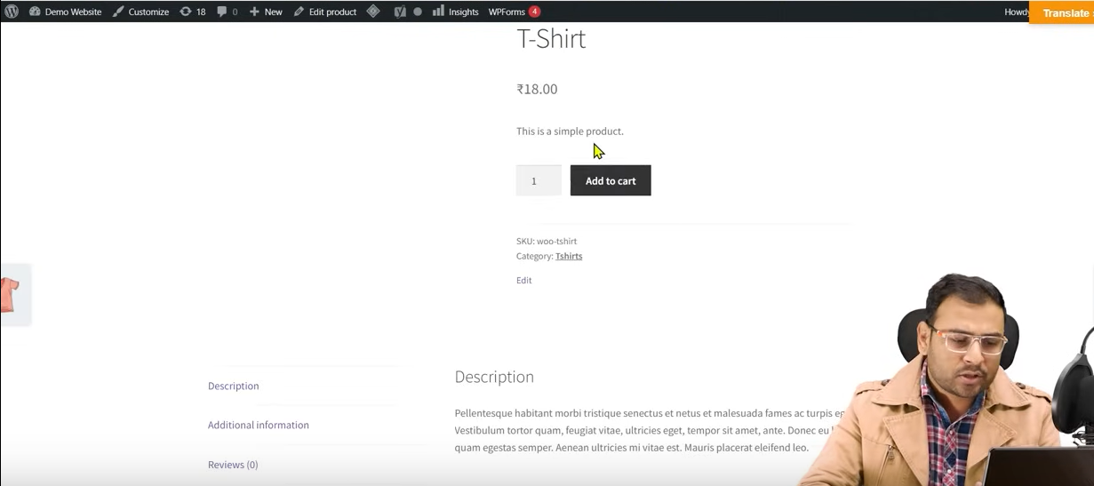

You say to the developer this is the attributes and you have to give them product wise

For developer it is easy because as they are already present in our website So for the developer it is not a very big deal that by writing some line of code dynamically make information feed

Then he/she will ask you what form they want it. H will give option in backend that you click on the button and your feed will be downloaded and will give you option that in which format you want to download whether in xls, excel,csv etc

So you have to show the developer the template you want to see the details in your feed

Now if we talk about mandatory things in our feeds then

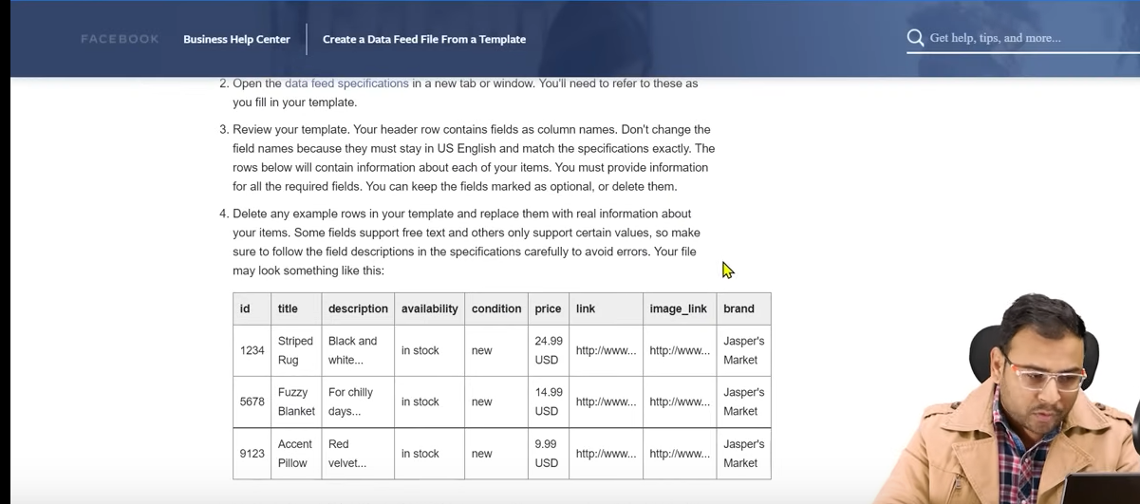

The columns you see above in the table are mandatory if you create your feed without them hen it will give you errors



The url you see above is of documentation. In this documentation it is written how with the help of templates you can create the feeds

Now if you tell your developer that I want above column then he will make an option in backend due to which when you click on that option you will download your deed in any format you want

If the developer is an experienced one then there will be o problem he will understand it when you say him to make a feed

For now we will see how to create a feed in wordpress website. NOw if we want to updae our cataog in field then we have many ways to do it.

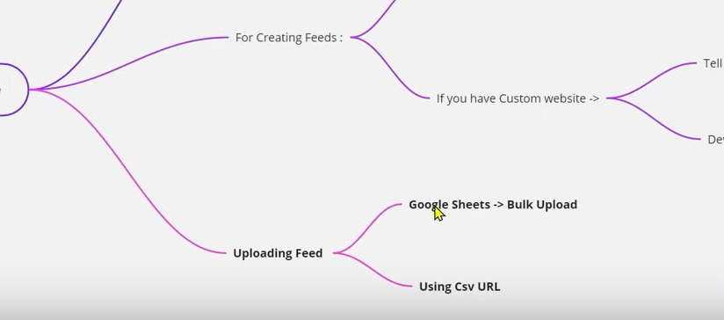

SO first way as you see above by uploading our feed to the google sheets first and now you connect google sheets to catalog then inside our catalog

So the catalog get populated with the product mentioned in our Google Sheet . The second way is that if we make a feed then that feed has a url and we put this url in our catalog and then it will be populated

The advantage with Google sheets is that it is easy to edit your product list in between the catalog by this way because if you bring changes in your Google sheet then it will be synched with the catalog measn chnge in sheet will be seen in your catalog but if you use the url way then if you update your website then it will be reflected catalog so ithing that google sheet methos will be helpful if you want to bring changes carefully in your catalog (I think so)

So by url way the changes in the website will not be reflected in the catalog but the changes in the Google sheet will

**Phase 92**

Unitul you bring changes in the feed you will not see them in your catalog if you want to bring changes or frequent changes so that you make feed becomes ad friendly that’s why you have to bring changes in your description it is said that this way is very safe and if you think you do not require to bring changes then you can use first way

Now if we come to wordpress backend and he has already installed the plugin . The plugin name is CTX feed as highlighted below

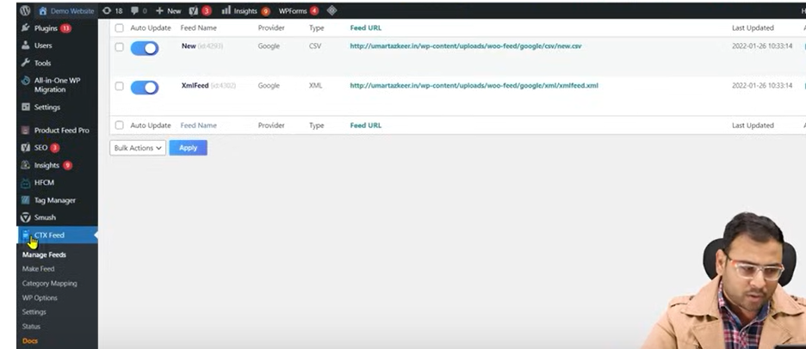

SO install it another is there that Product feed pro . It also help us in creating feed

Now we click on the highlighted CTX Feed then

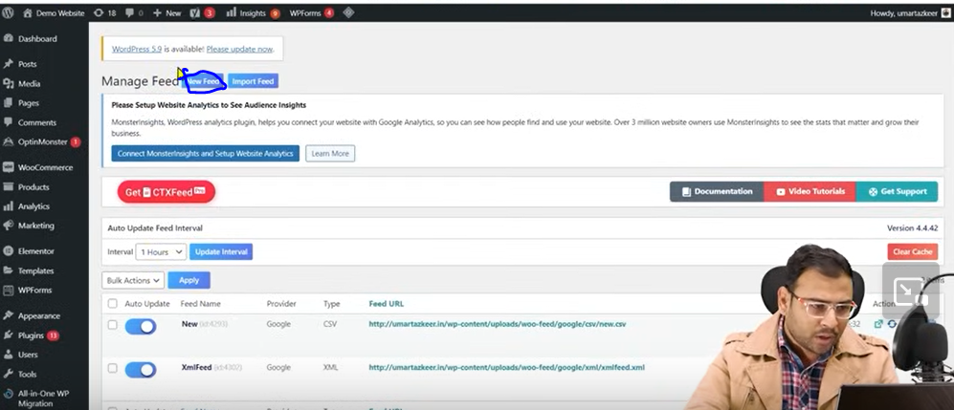

Now click on new feed button as marked above to create our feed

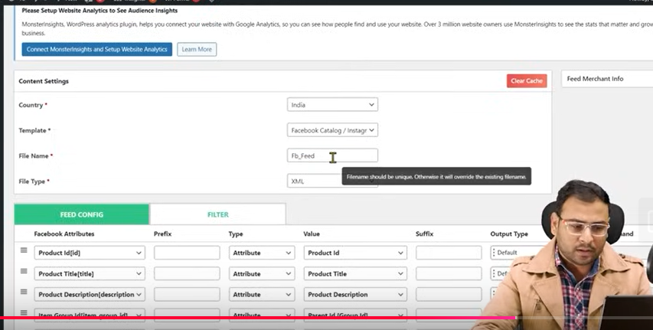

Now the above opens

Now we enter our Country, Template, File Name, File Type(means the structure)

We choose CSV instead

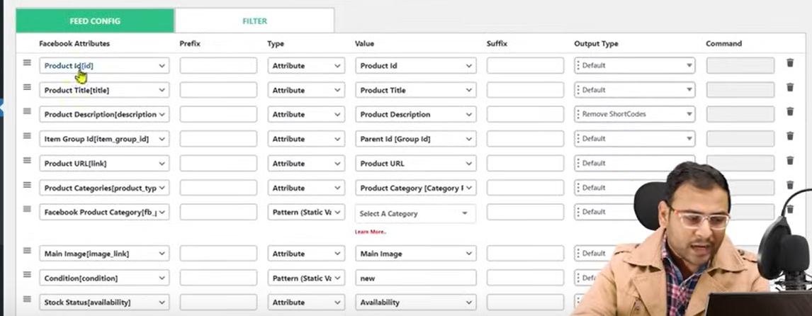

SO from above image we see that it will pick up product id’s , title, description

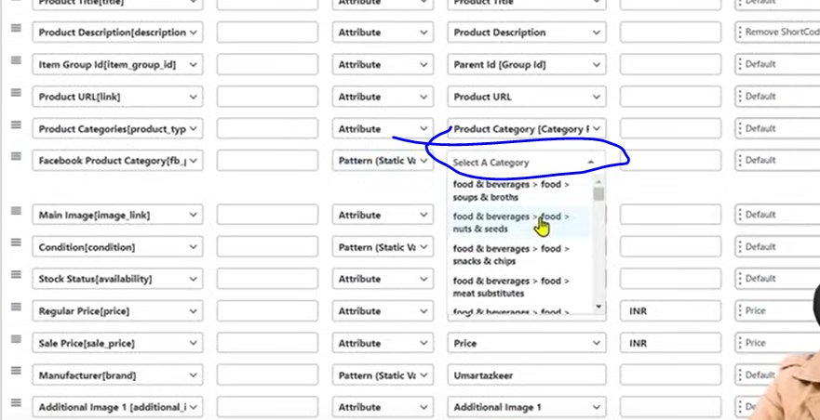

Now in marked above choose the category you want your product to fall in

Maybe now click on update and generate feed buttom

The creation time depend on how many product you have

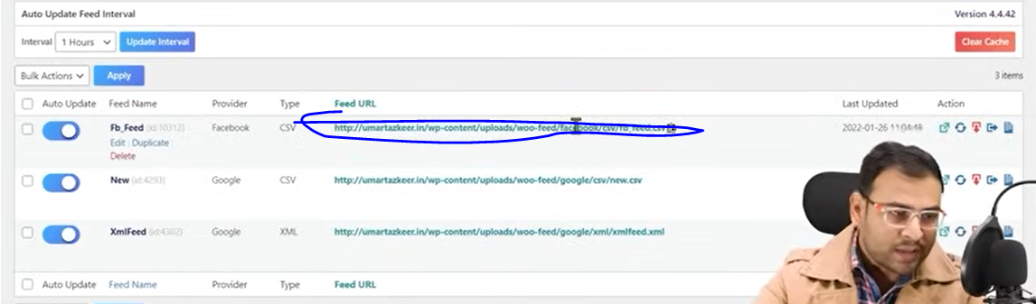

Now you can use the above marked url in your catalog

Now we come to our commerce manager and we have seen how to make catalog here

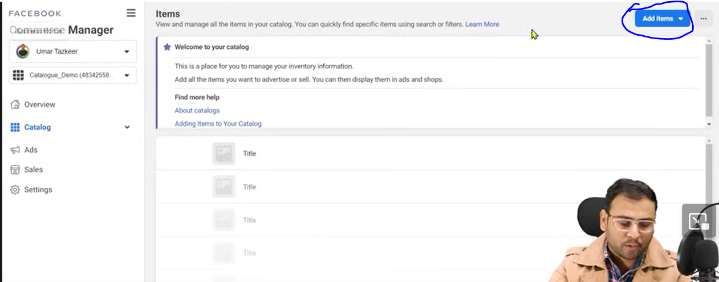

Now click on the Add items button as marked above and in submenu choose multiple items

And then in new UI

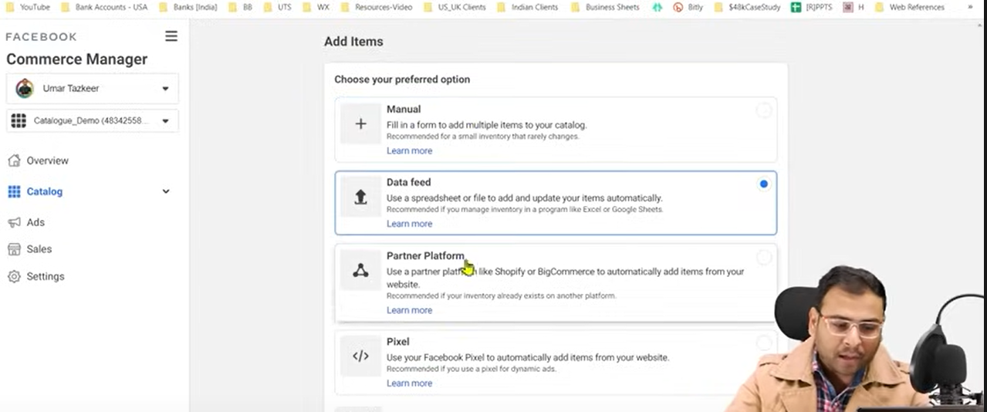

In manual option you tell the product one by one but in Data feed you do it by feed

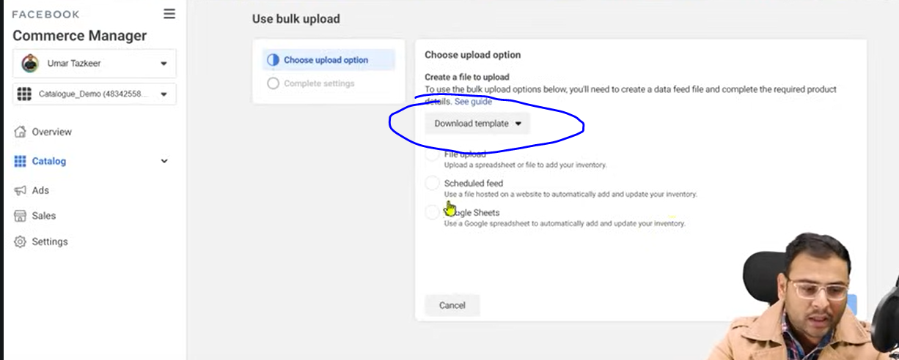

NOw click on next you will see the UI above

We get three option to data feed as shown above that is File upload, Scheduled upload, Google Sheets

We ignore File upload and choose one of the other two

By clicking on marked above you can download the template that will be used while creating catalog

SO we will go through URL way so we choose Scheduled feed radiobutton

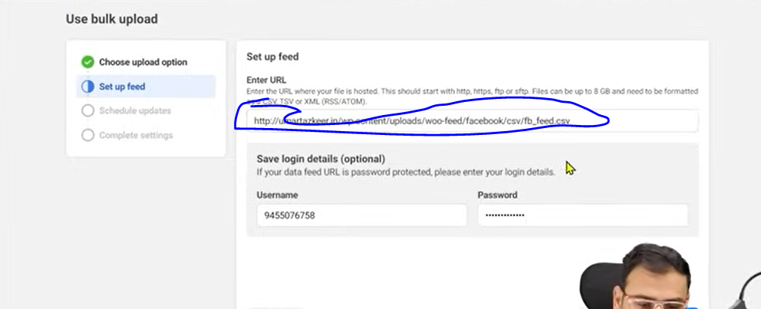

Now in above marked area type your feed url of the feed we created in wordpress above

Now click on next button

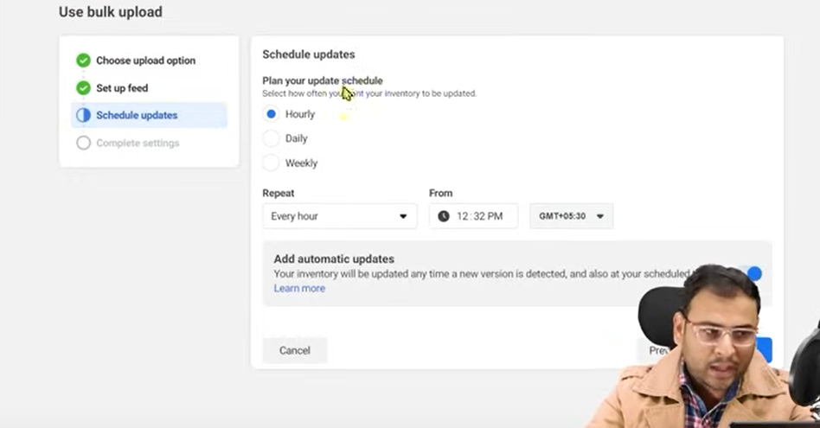

And now we get the option

Sometimes you update the product in your website Now if you update then you need to update the feed also

Now since the feed changes you have to tell the catalog that our feed is changed

These things happen by default and the synchronization should be maintained that’s why we have scheduled updates option here . NOw we have connected the feed . Now our catalog will take updated from feed is there any chages in the feed or not

You can now choose the schedule you want to follow whether Hourly, Daily, Weekly

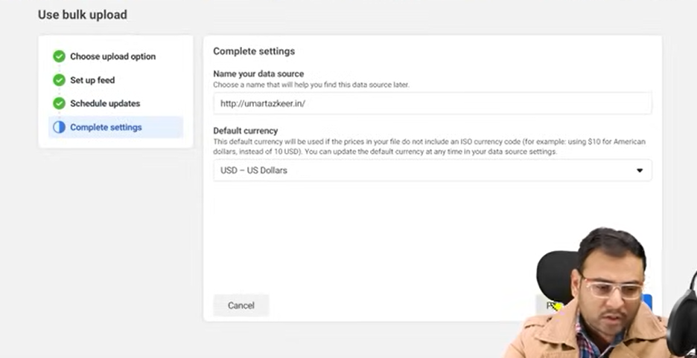

Now we choose our currency

In data oure you tell the source that is our website url

Now we click o upload button

NOw if I do something wrong means our product information is not correct

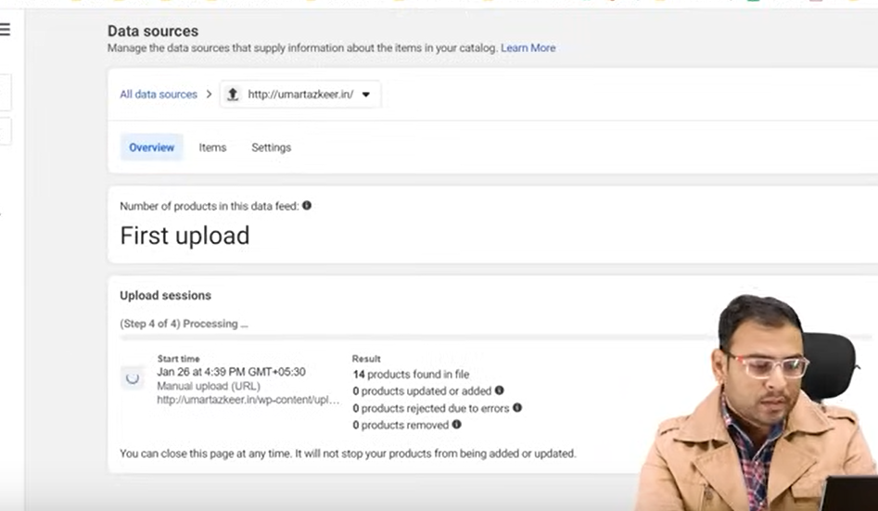

Then we will see the error here

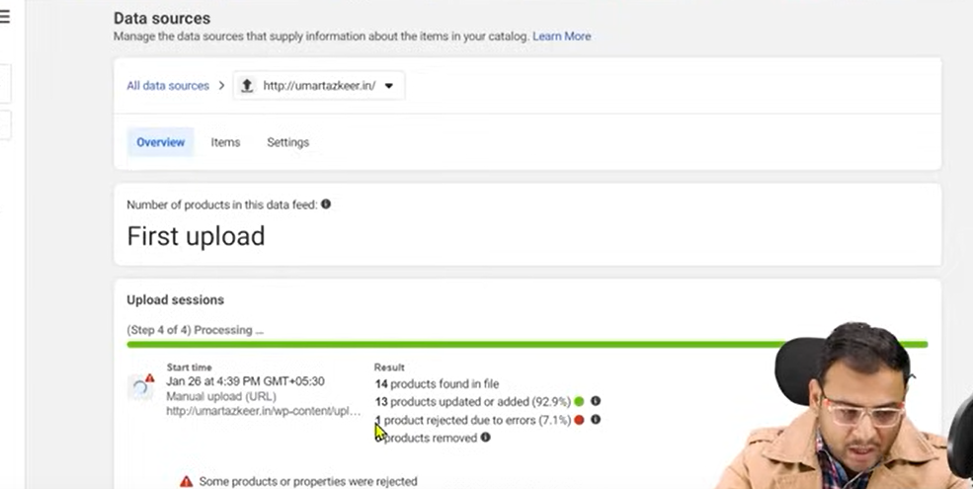

NOw in above it shows there are 14 products in the file 13 are added and there 1 error in the product

Now if you go to report then you can see its report

It is because in the website the information is like dummy

But if your products I you website is proper then you will not get those errors

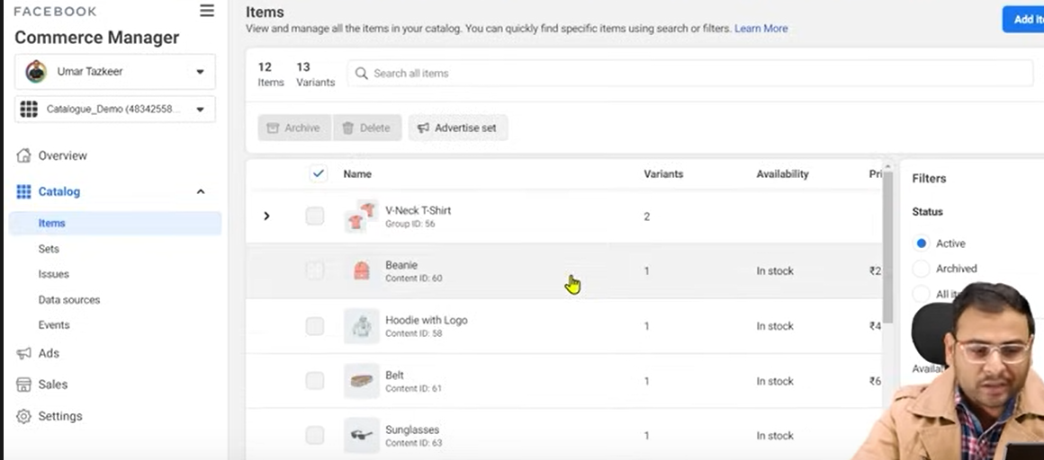

Now if you go to Catalog> Items then you see all the items in your catalog above

Now we will go with the Google sheet method that is second method

Now we go to Catalog>Data Source

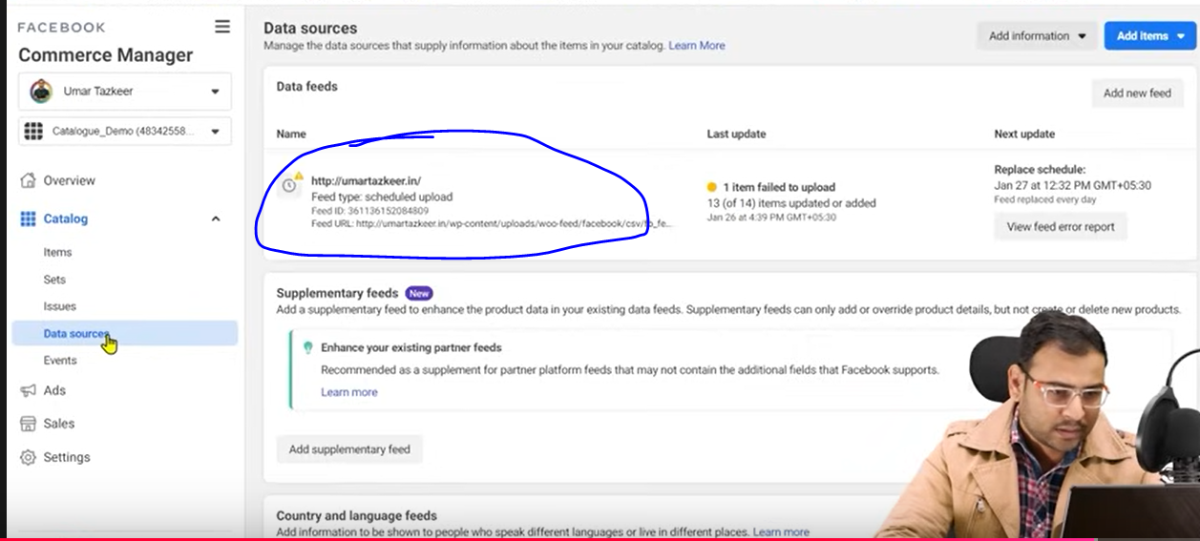

Now here we decided to delete feed so we click on marked above to create our catalog data sources

We go to the data sorce() mabe feed

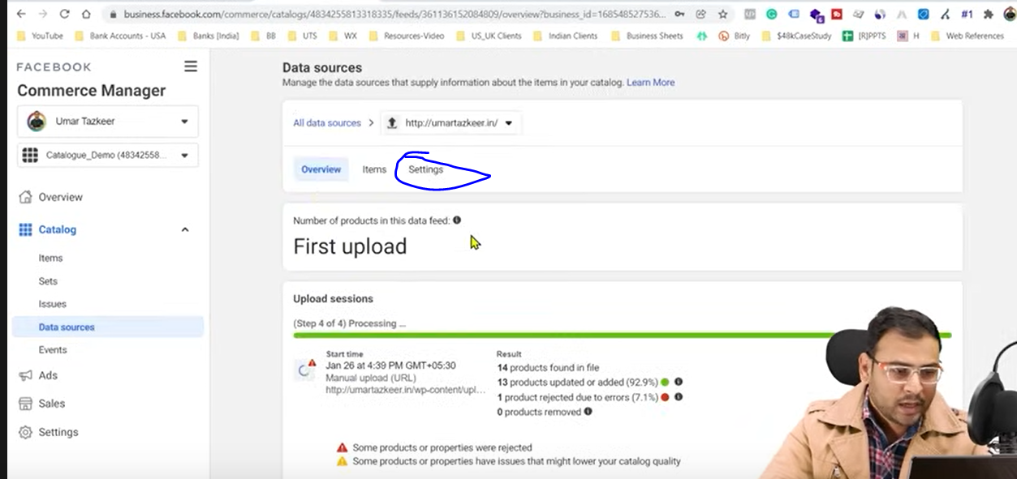

Now in new UI go to settings tab

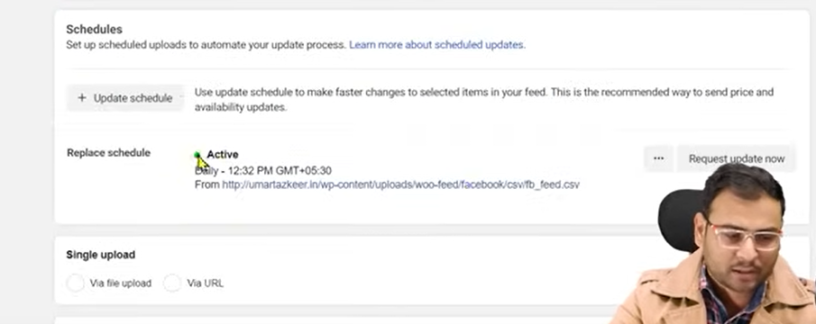

Now in replace schedule we see the schedule we set for our updation

Now click on delete buttion to delete it

As ou feed was already formed wordpress

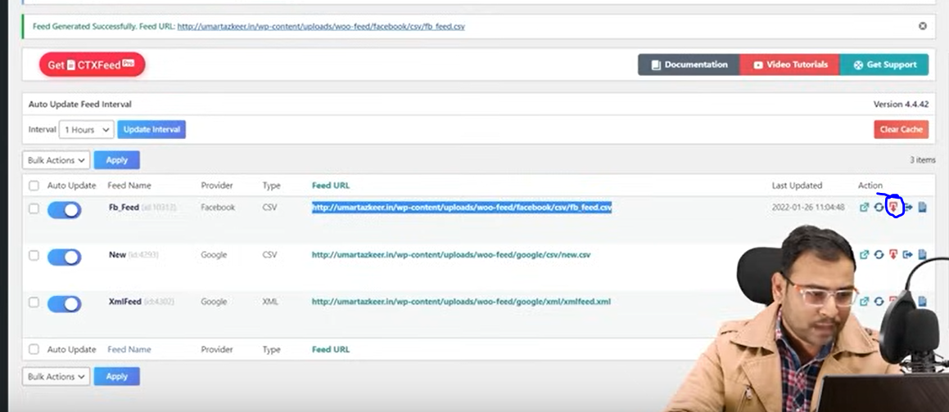

So we click on the marked above to download that feed but it will be download in txt format do we need to convert into excel file so for that

NOw if you try to open this file with excel then

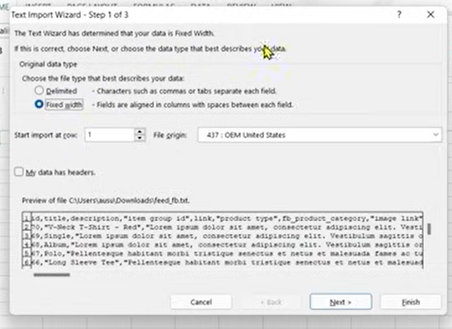

Now it will open the wizard as shown above

Now choose the delimited and in file origin chose

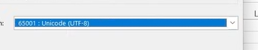

Above option

Now check the checkbox My data has headers

NOw click on next

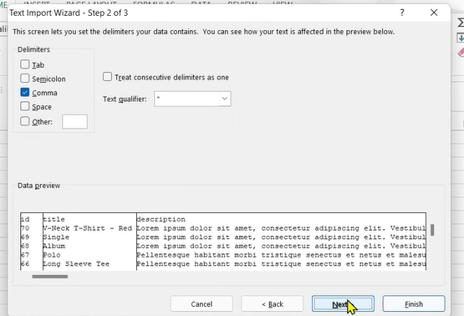

Now in delimiters choose Comma   
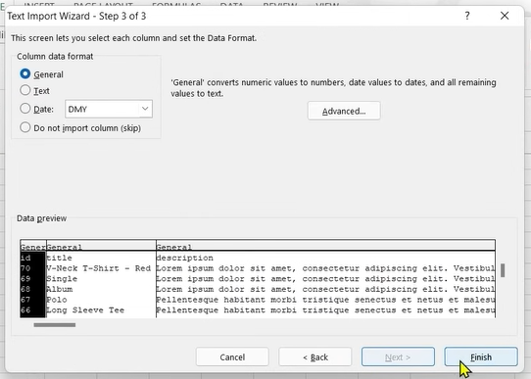

And now click on Finih button

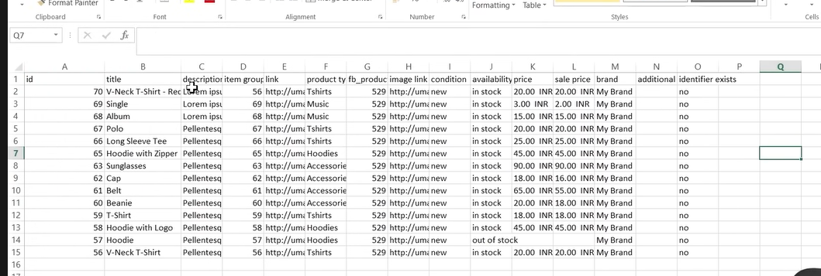

Now you can see your product as shown above

Now it is in excel previously it was in url

But now we will upload the data to Google Sheet

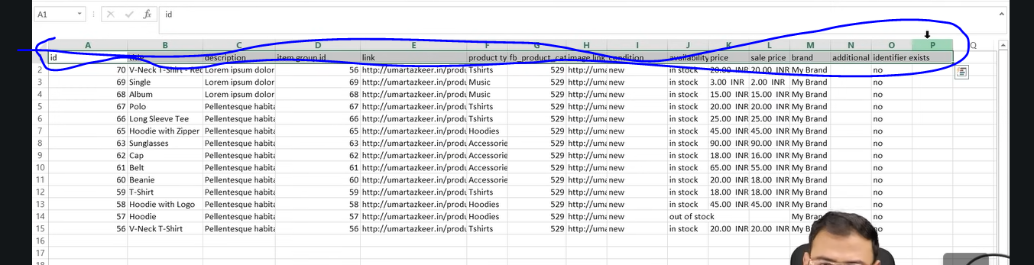

Now we need to give the headers as marked above to the developer

And say bring my product information in this format

We paste it in Google Sheet

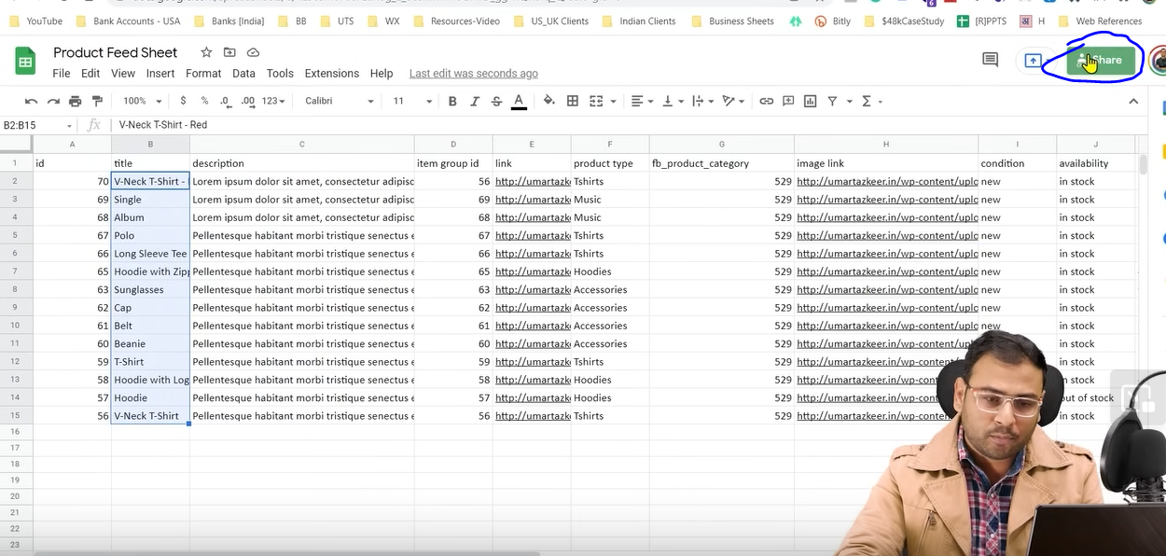

Now we click on share button as marked above

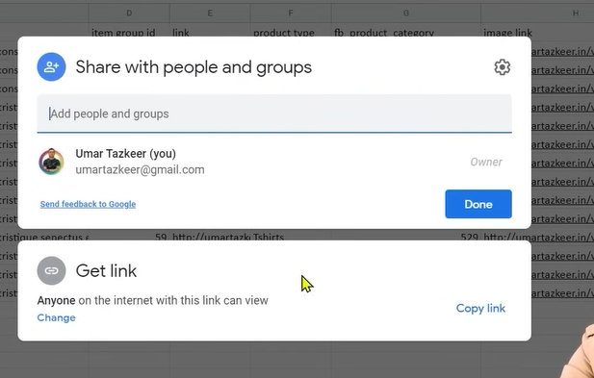

NOw a prompt will be opemed like above

Now click on copy link to copy link

Now in Commerce manager choose Data feeds

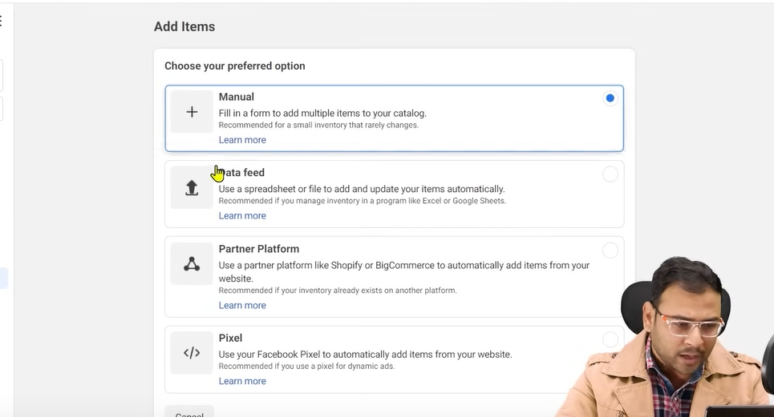

And now click on Next button

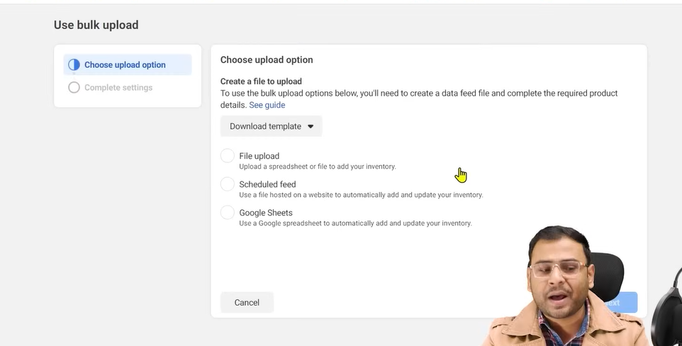

Now click on Google Sheets option and then click on next button

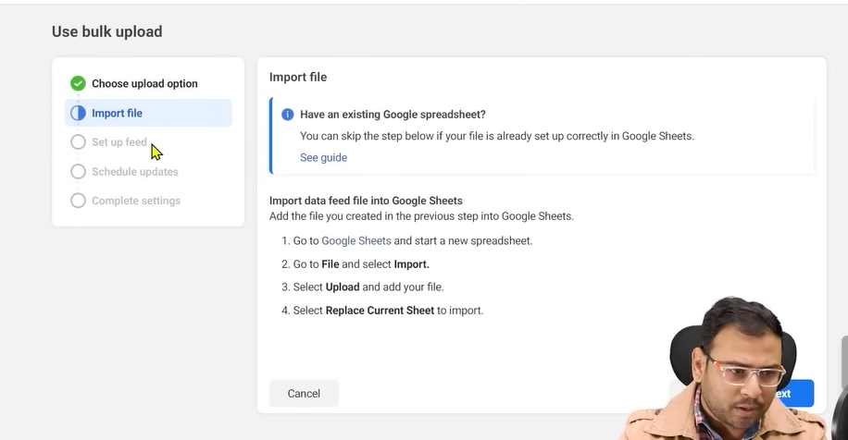

Now again click on next button

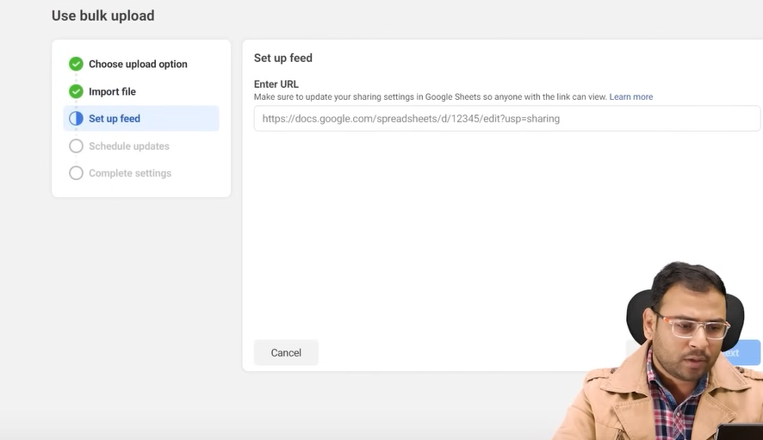

Now paste the url you copied Now click on next button

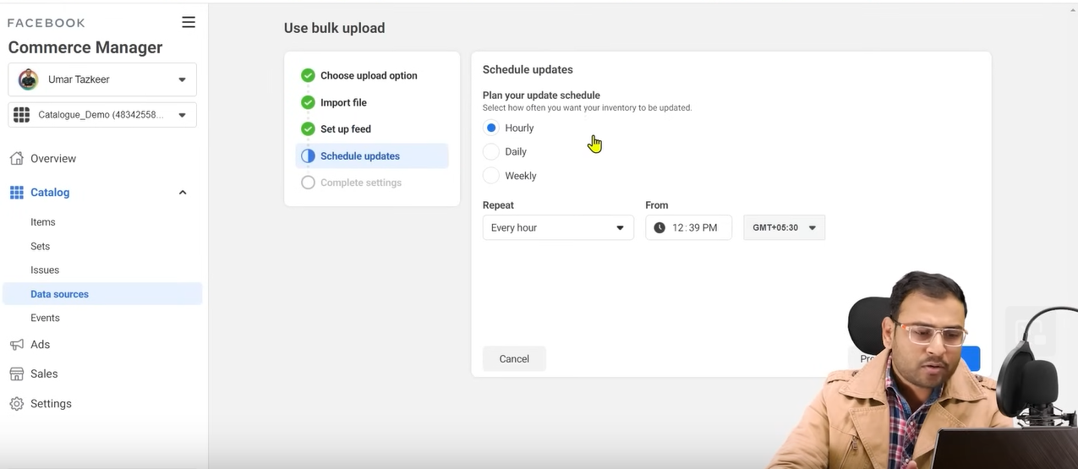

Now we set the schedule

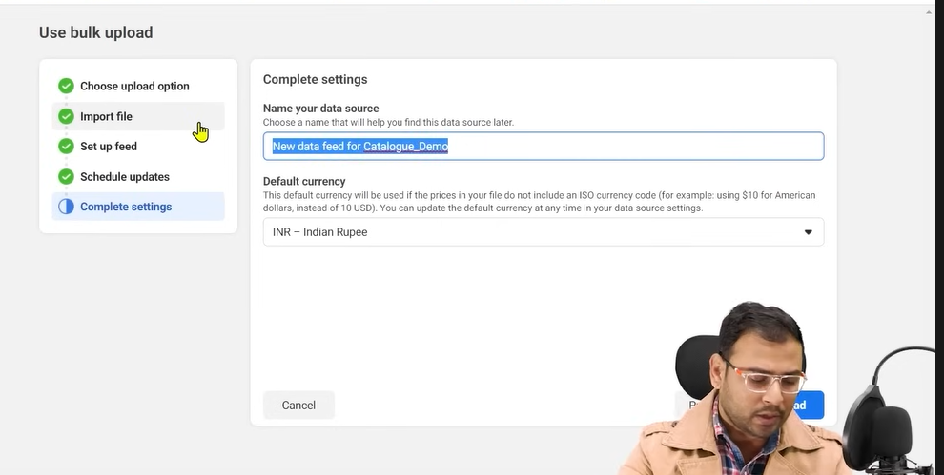

And now we set the data source name and then set the default currency we set it to INR